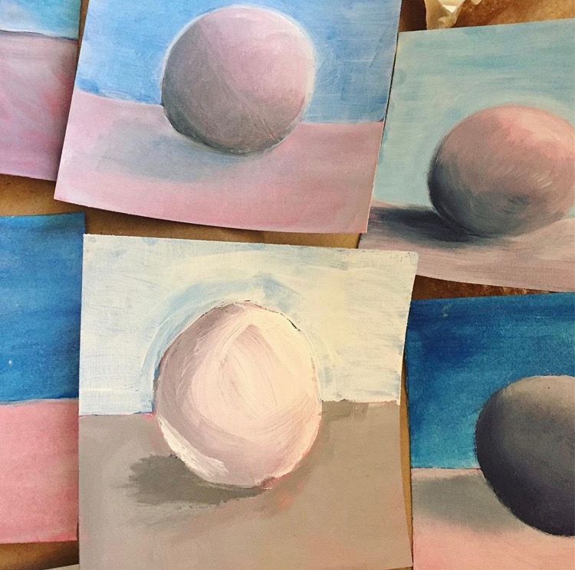

As an introduction to the landscape unit, students were led through a series of technique lessons in painting objects in space, by creating the illusion of light and form. As a warm up for painting specific shapes that might be found in landscapes, like a cylinder, students were asked to start this exploration with an object they were familiar with from Intro to Art; a sphere. We also explored the technique of underpainting, which could be used in their landscapes later on in the unit. As described in my supervisor’s observation, I did a demo of underpainting a sphere, and was observed helping students with misconceptions of where to place midtones and the darker colors for the shadows.

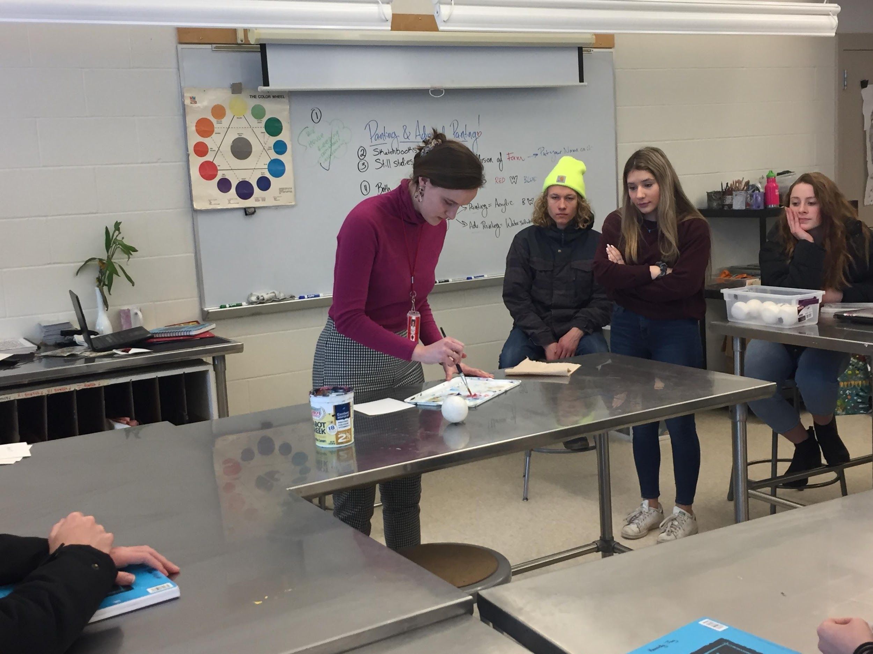
Class began with some “housekeeping” and then transitioned to the day’s work. You began by doing a demonstration of an underpainting using red and blue. Using a lacrosse ball as the still-life object, you talked through your decision-making process while you painted, pointing out the shadows and highlights. As you finished the demo, you remembered to let students know why they were creating an underpainting- to help liven up their painting-. I liked how you told the class, “I’m learning”, and asked them to just go ahead and ask you “why are we doing this?” if you ever forget. Great way to model that we are all always learning.
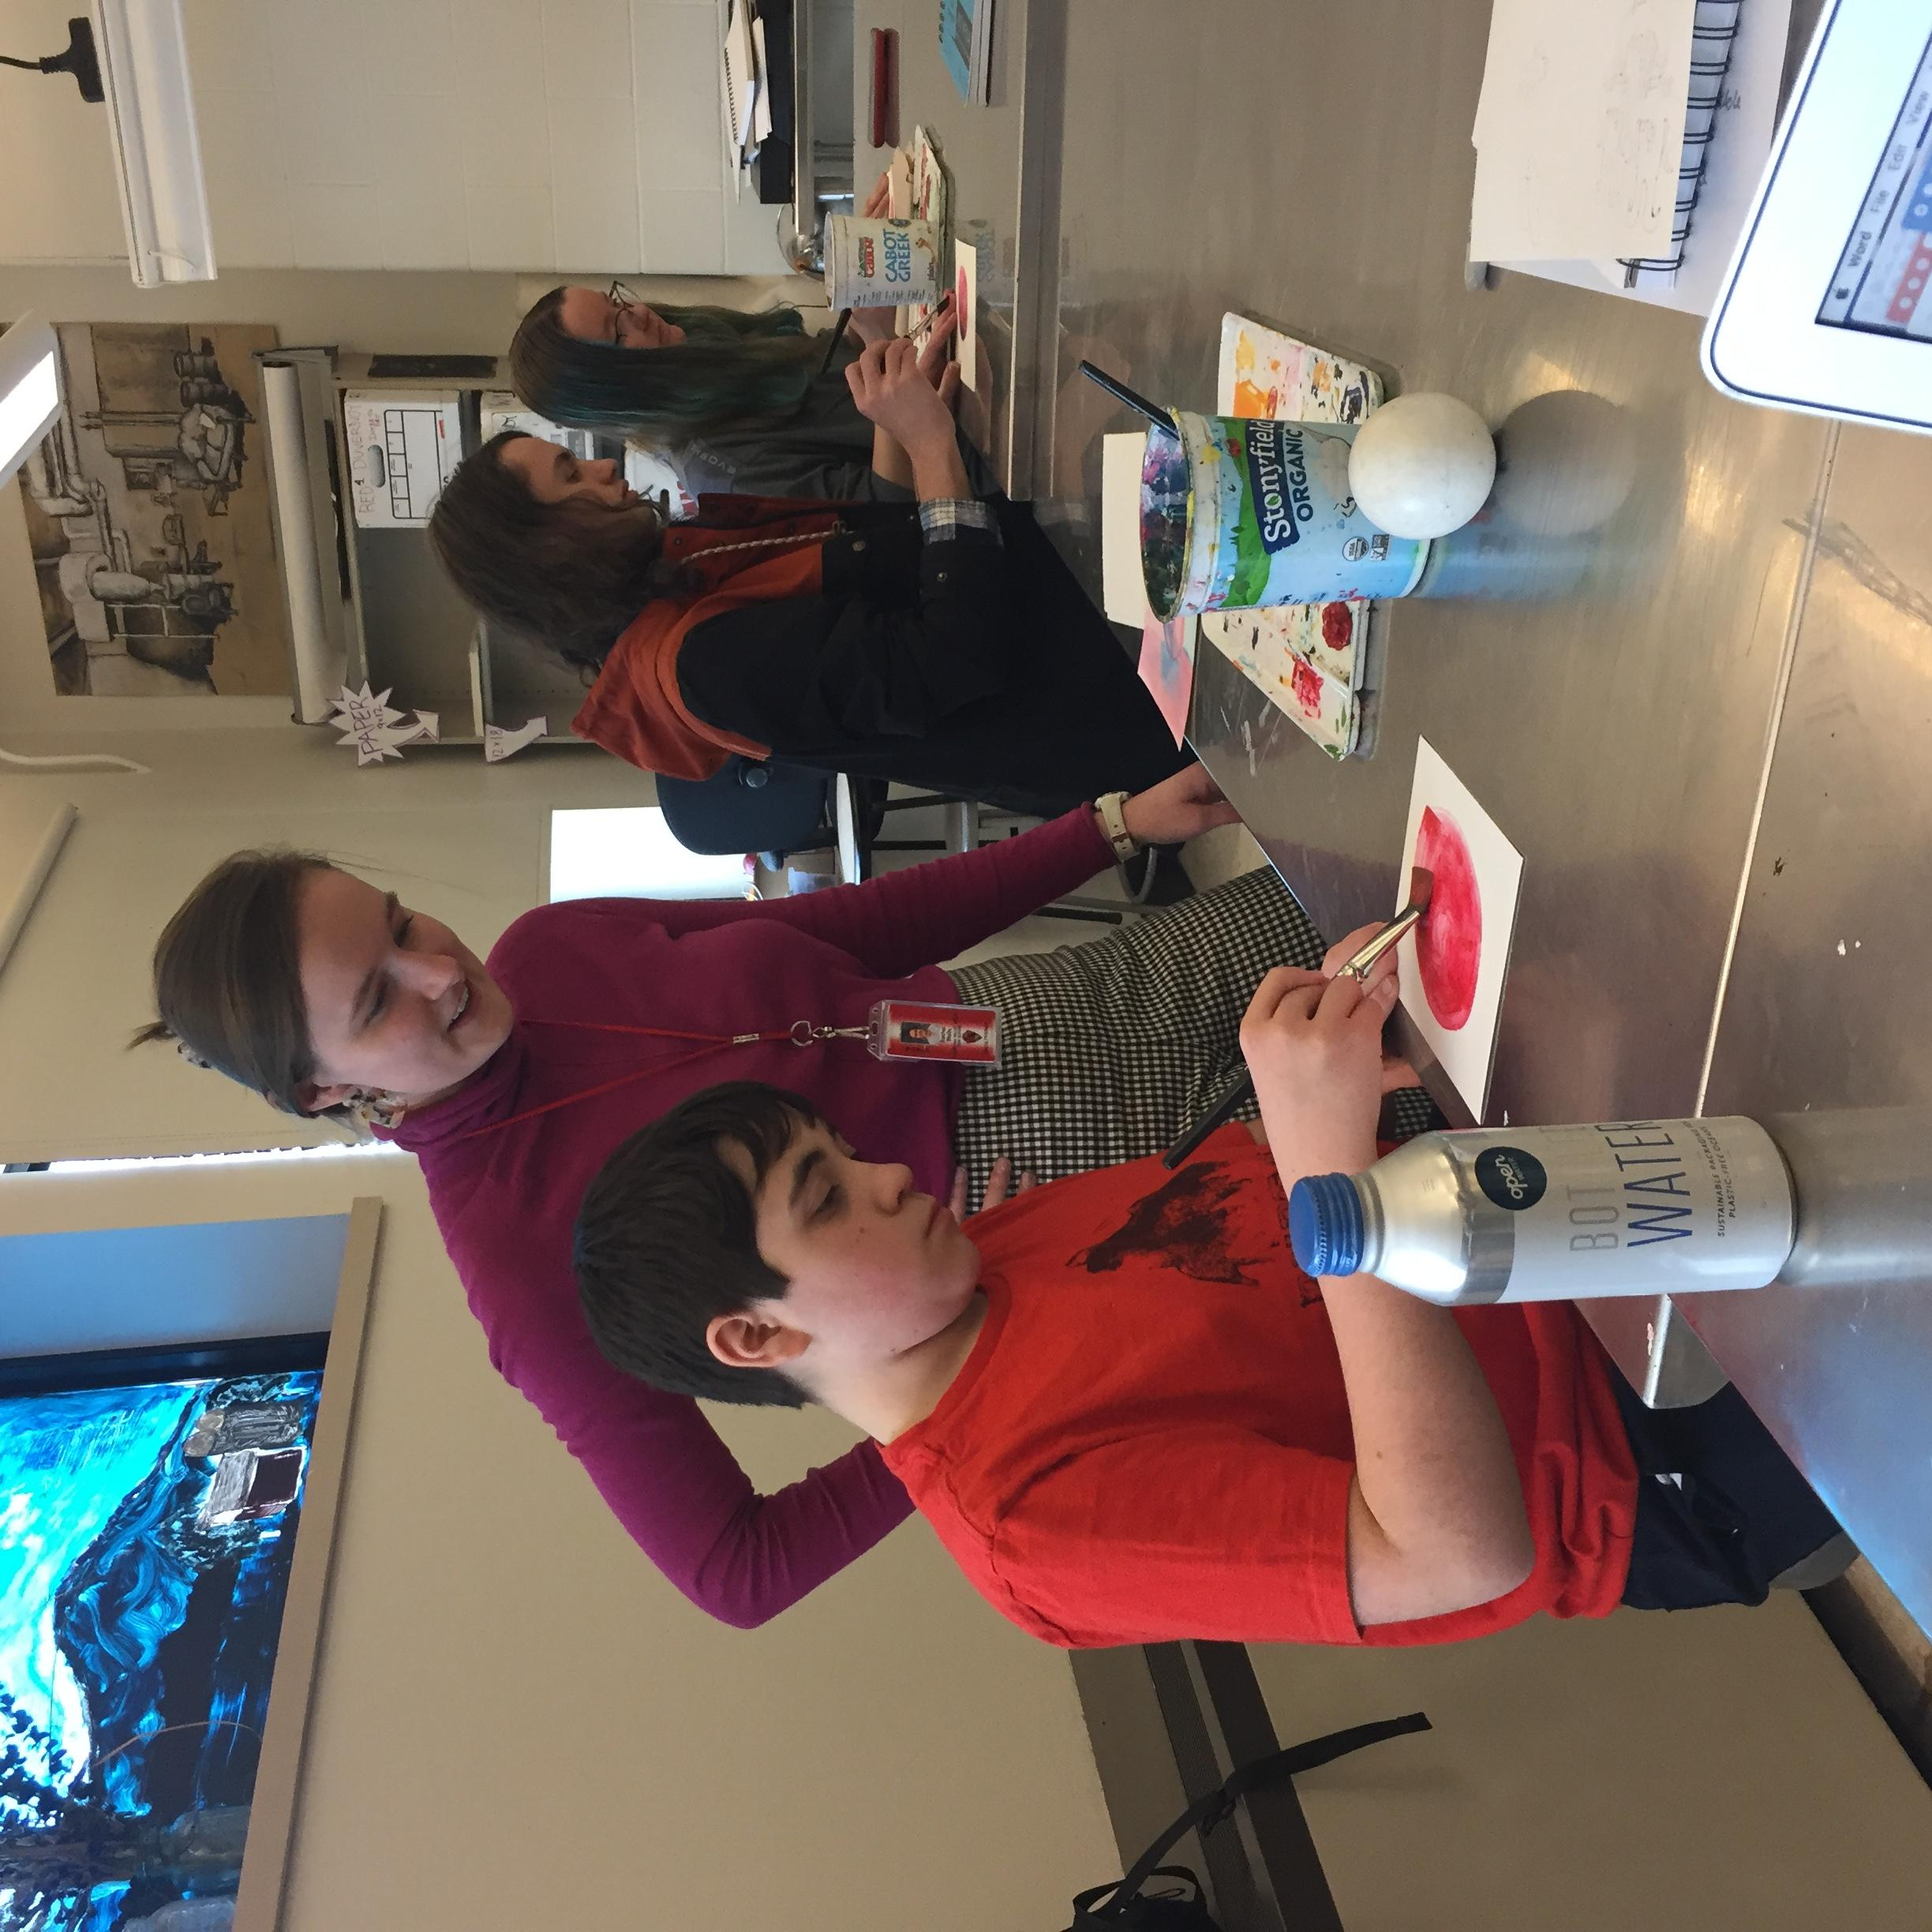
There was a student who started off with blue instead of red paint. I thought you handled this beautifully with such a sensitive and encouraging way. When you noticed, you gently said, “I think we had a miscommunication, you and I.” You helped this student find another piece of paper and got them started again. This student needs quite a bit of support but you were able to balance that with moving around the room to check-in with other students as well. You kept your eyes moving around the room- this was great and seemed like growth since my last visit.

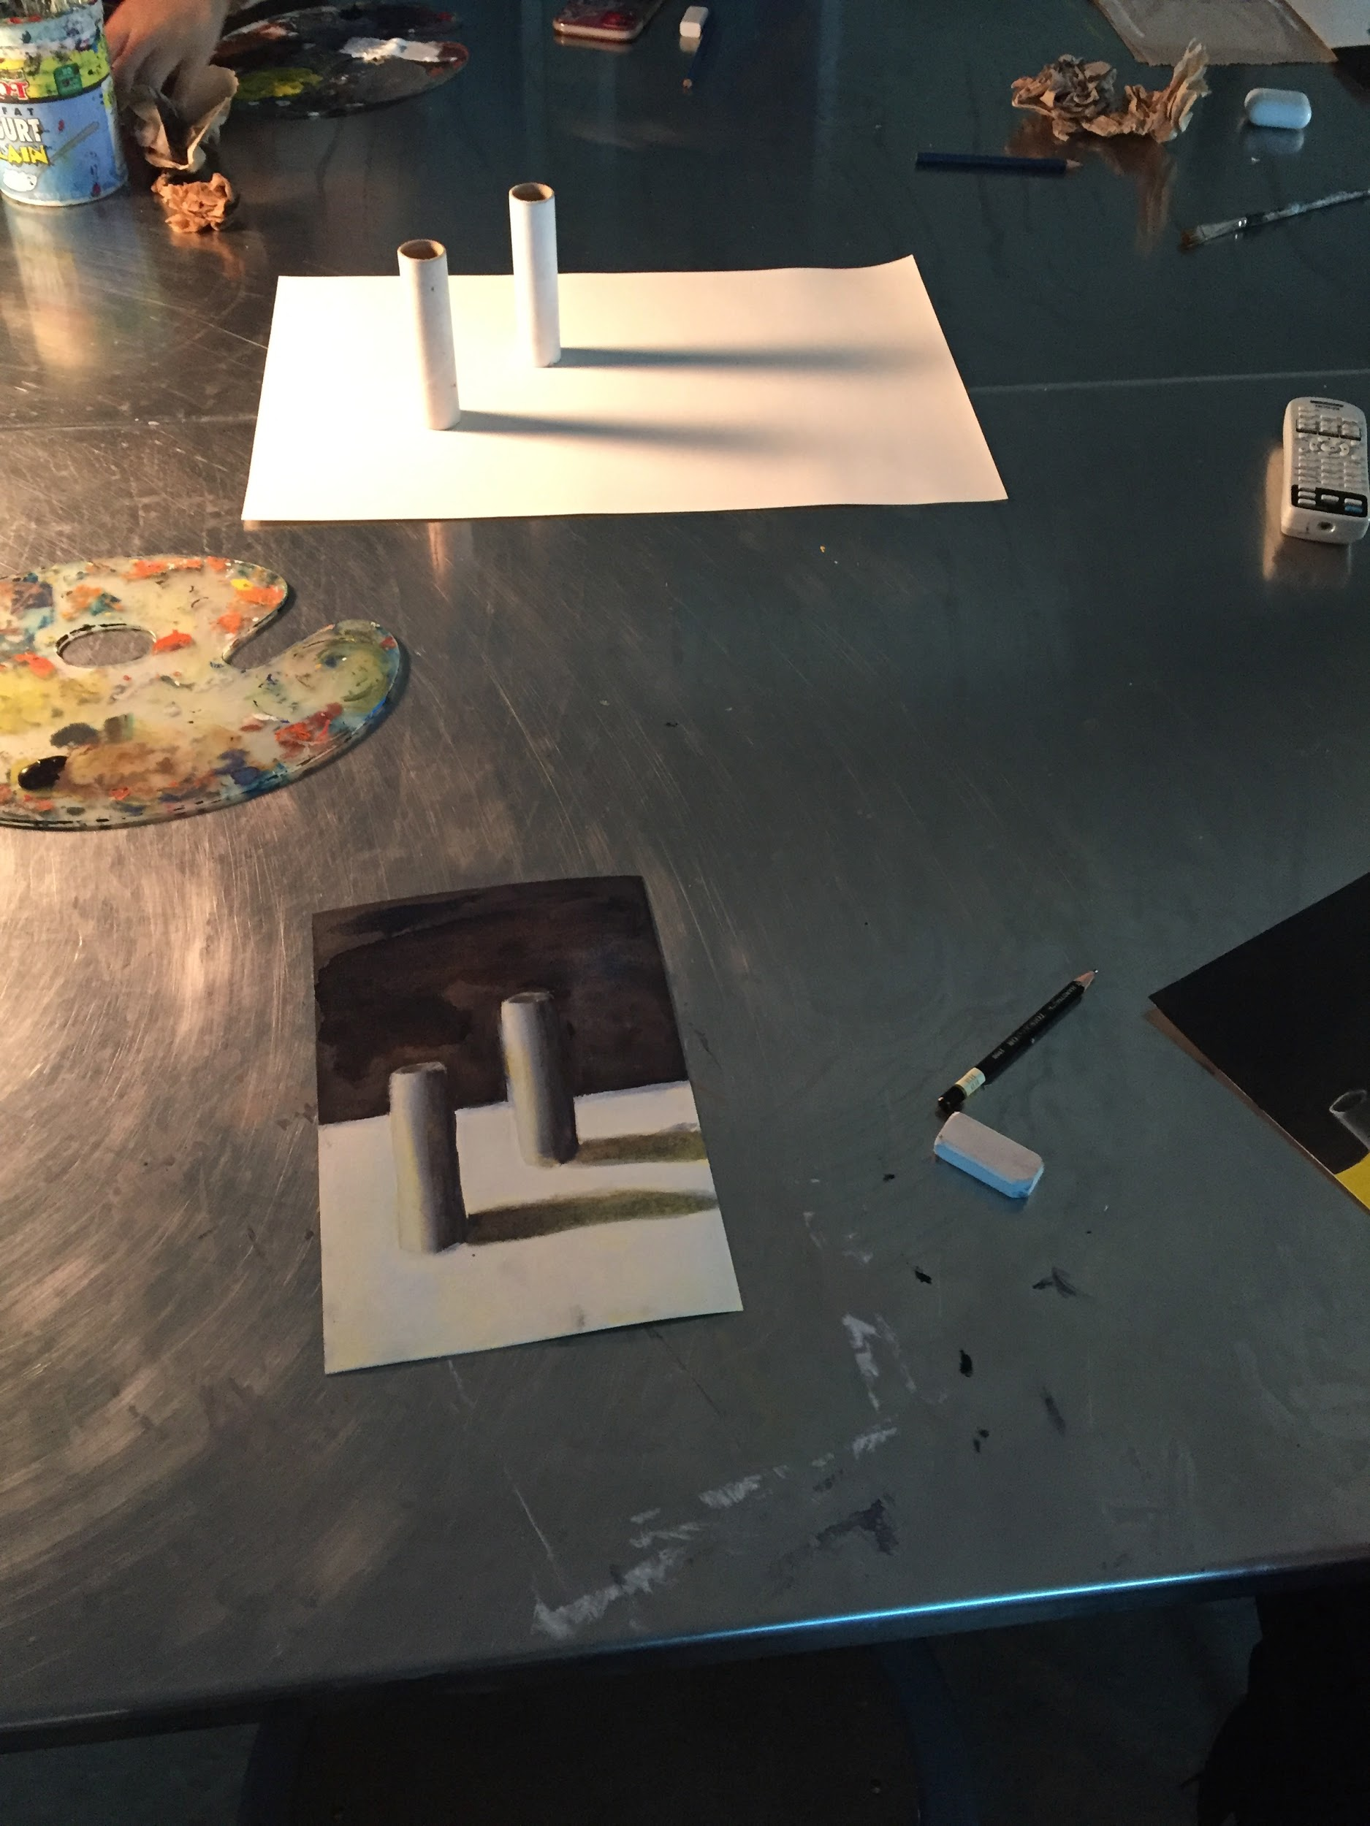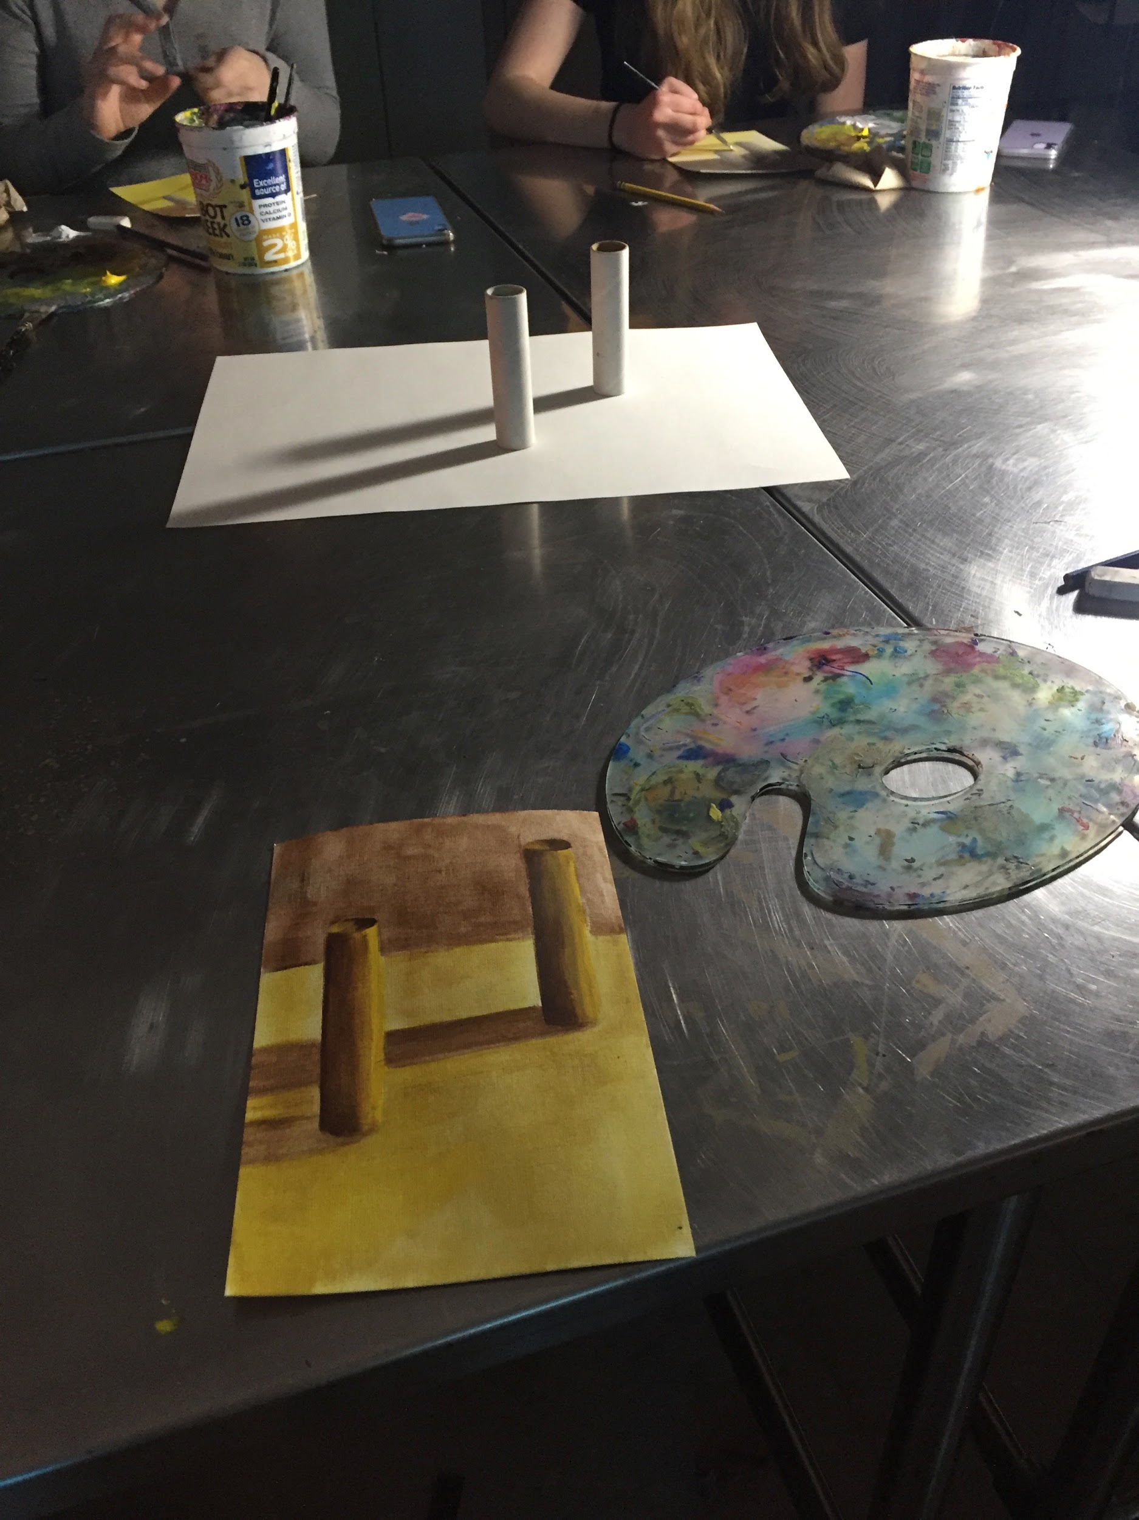
The second lesson for this unit and the practice of painting the illusion of light and form involved a demonstration of how to draw ellipses in painting class, and explaining all of the ways that they are commonly drawn inaccurately. This was part of the underpainting life study lesson where we painted tubes with brown and yellow underpaint. This lesson gave students the tools needed to use a different set of underpaint which they may prefer over using blue and red, and it gave them the skills to paint a common shape found in Vermont landscapes. Each of them would be painting a Vermont landscape at the end of the unit. Cylinders are commonly found in silos, columns, fence posts, and street signs. Getting the proportions of the tube/cylinder and correct shape of the ellipse top was something we were looking for in their still lives. I started this lesson by showing students the five different ways that ellipses are drawn inaccurately and I then showed them how to draw a cylinder accurately. Everyone then started their observational sketches of the tubes in front of them with the ellipse at the top. I left the examples of right and wrong on the board for reference as they completed this first step. Then we reviewed the observation measurement technique of using one unit of measurement and counting how many units fit within the dimensions of our tube, to draw it proportionally. I started demonstrating this on the board, and students then tried it on their own. Check-ins were made with every student to ensure they understood and were able to draw the tube accurately. I think the strongest part of this lesson that relates to the PC is the beginning of this lesson, when I went over the common misconceptions of how to draw an ellipse.

