Rachael Wells
Painting & Advanced Painting
February 11, 2019

Introduction to light and value to create the illusion of form using a still life object (sphere)

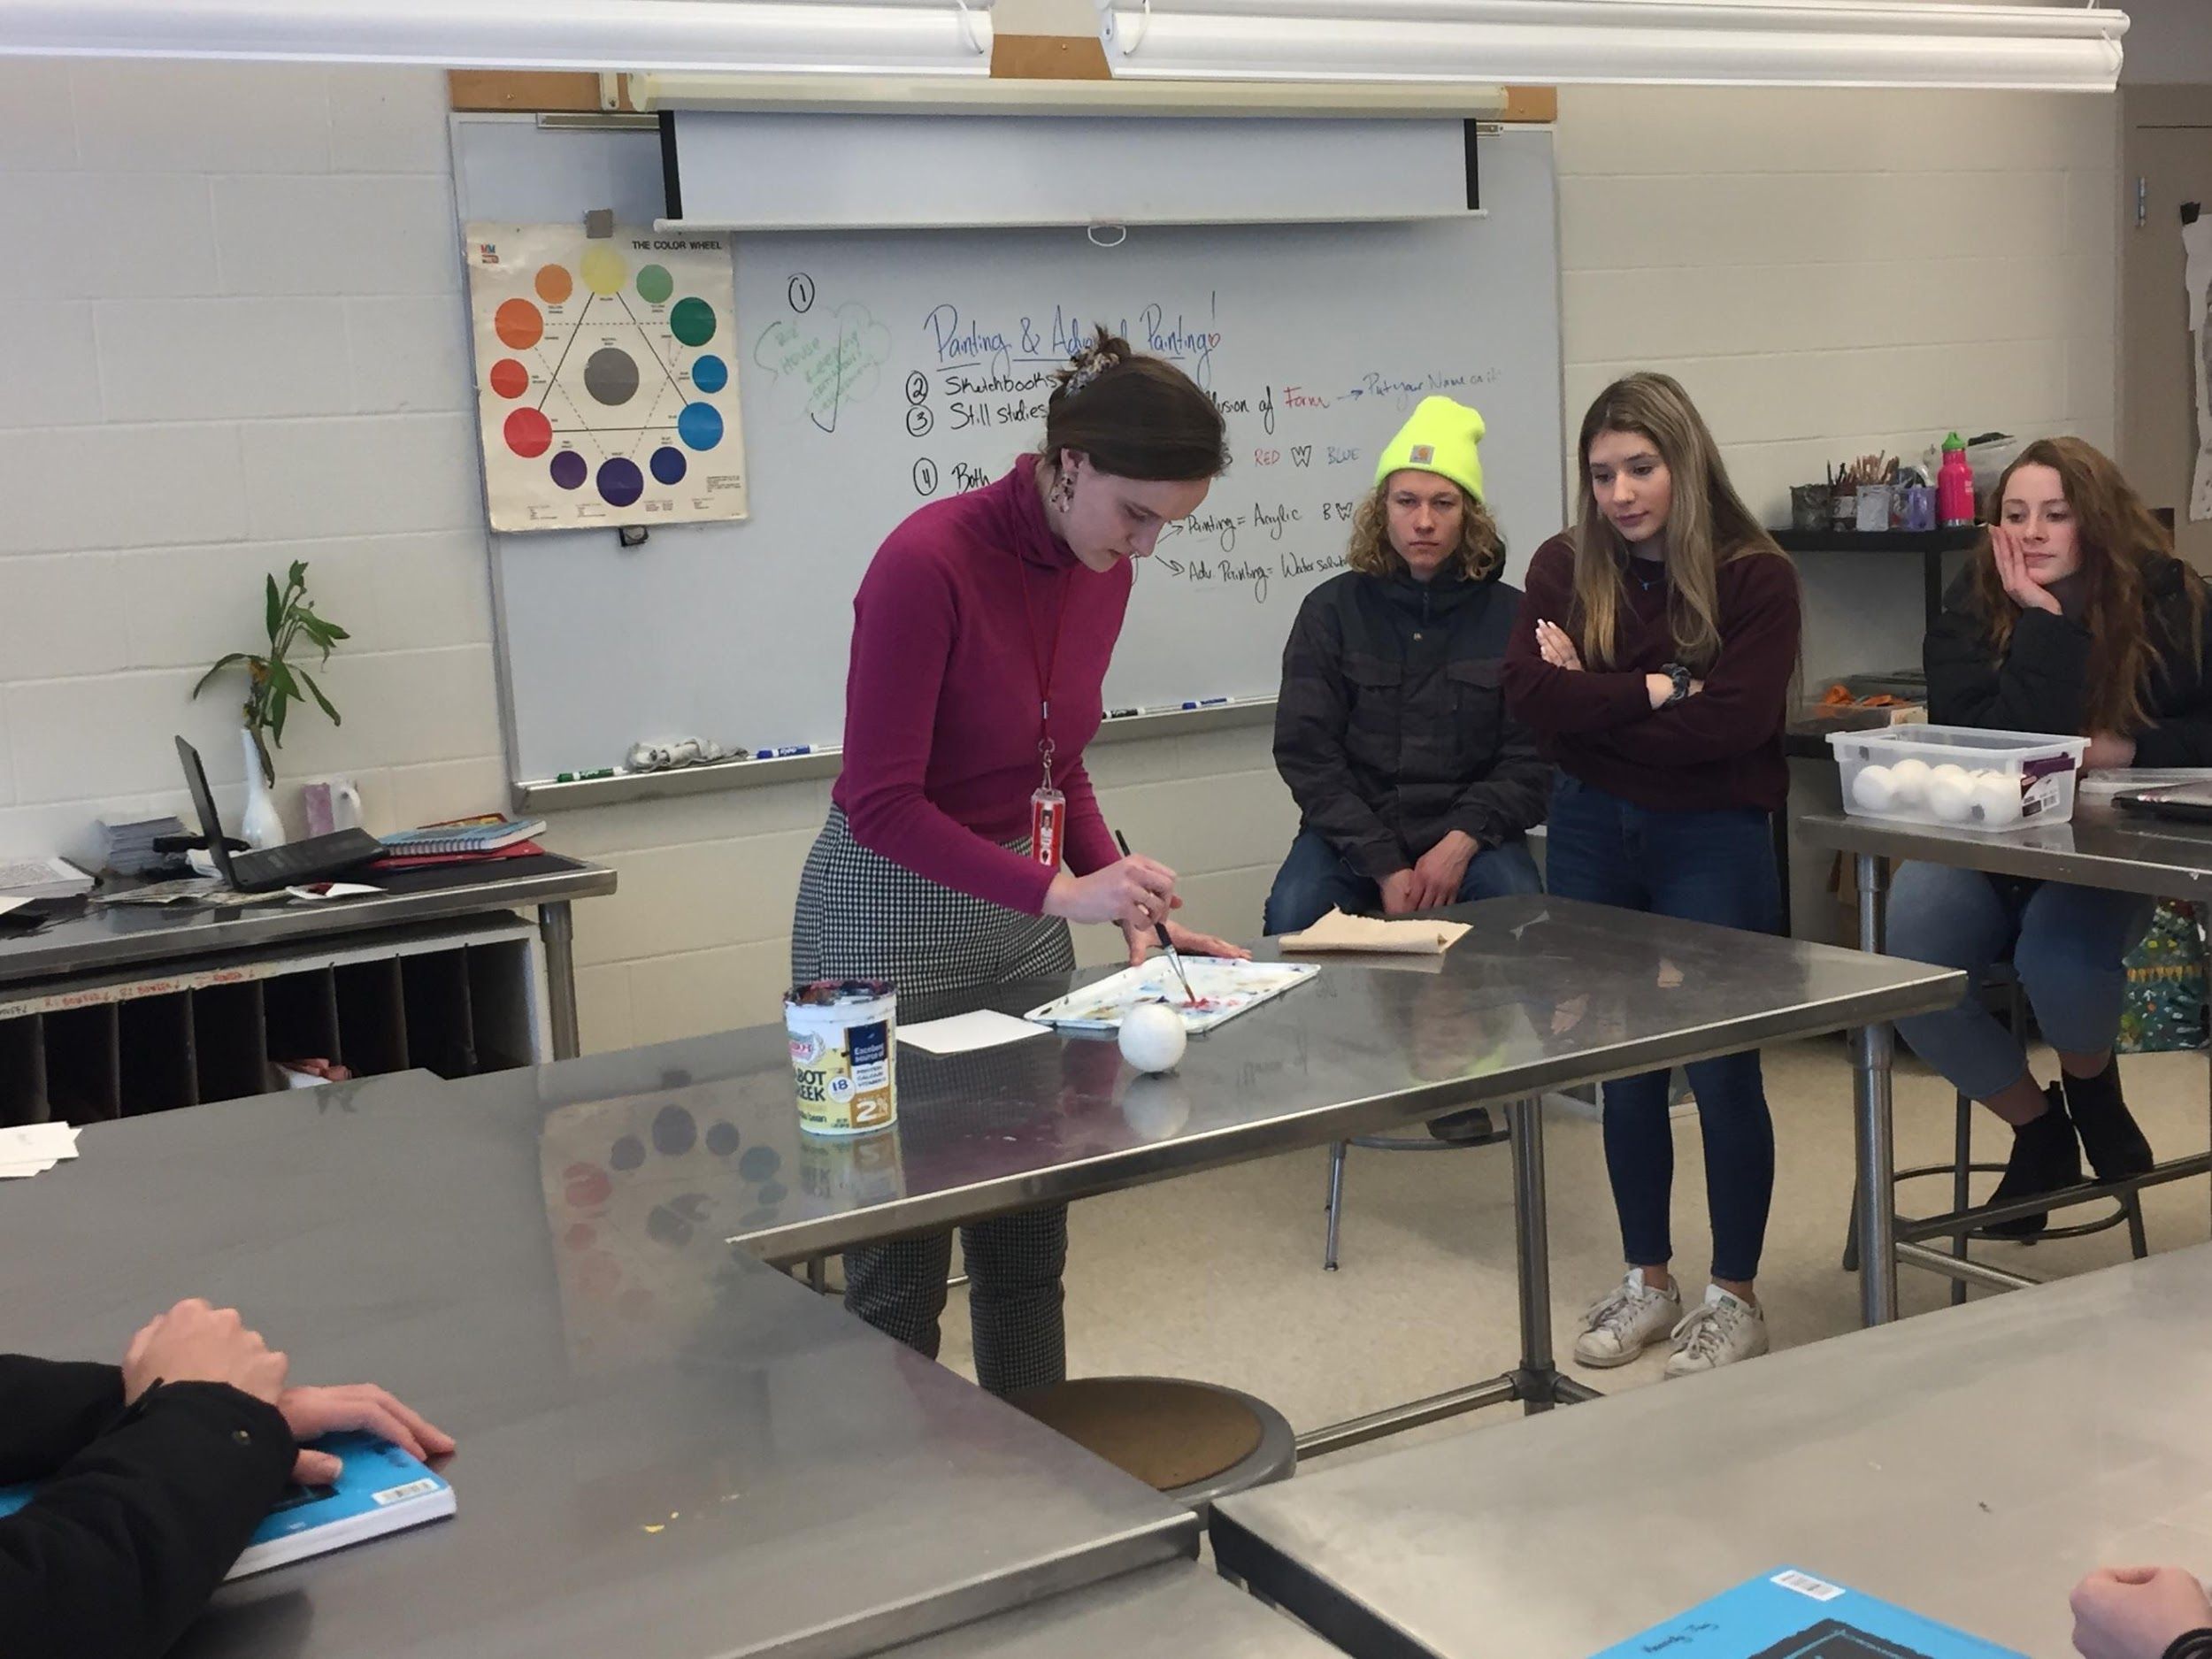
Class began with some “housekeeping” and then transitioned to the day’s work. You began by doing a demonstration of an underpainting using red and blue. Using a lacrosse ball as the still-life object, you talked through your decision-making process while you painted, pointing out the shadows and highlights. As you finished the demo, you remembered to let students know why they were creating an underpainting- to help liven up their painting-. I liked how you told the class, “I’m learning”, and asked them to just go ahead and ask you “why are we doing this?” if you ever forget. Great way to model that we are all always learning.
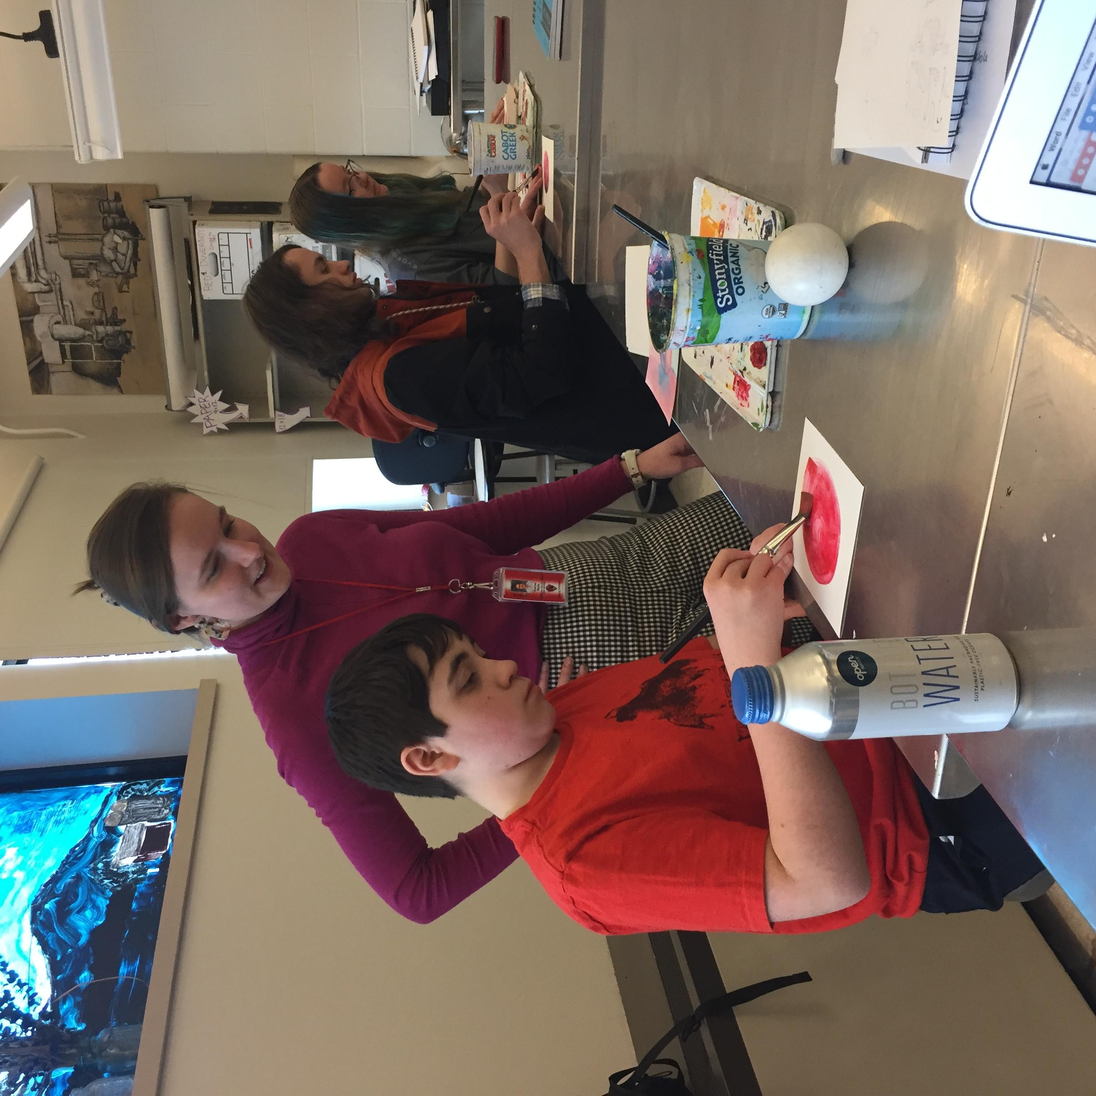
There was a student who started off with blue instead of red paint. I thought you handled this beautifully with such a sensitive and encouraging way. When you noticed, you gently said, “I think we had a miscommunication, you and I.” You helped this student find another piece of paper and got them started again. This student needs quite a bit of support but you were able to balance that with moving around the room to check-in with other students as well. You kept your eyes moving around the room- this was great and seemed like growth since my last visit.

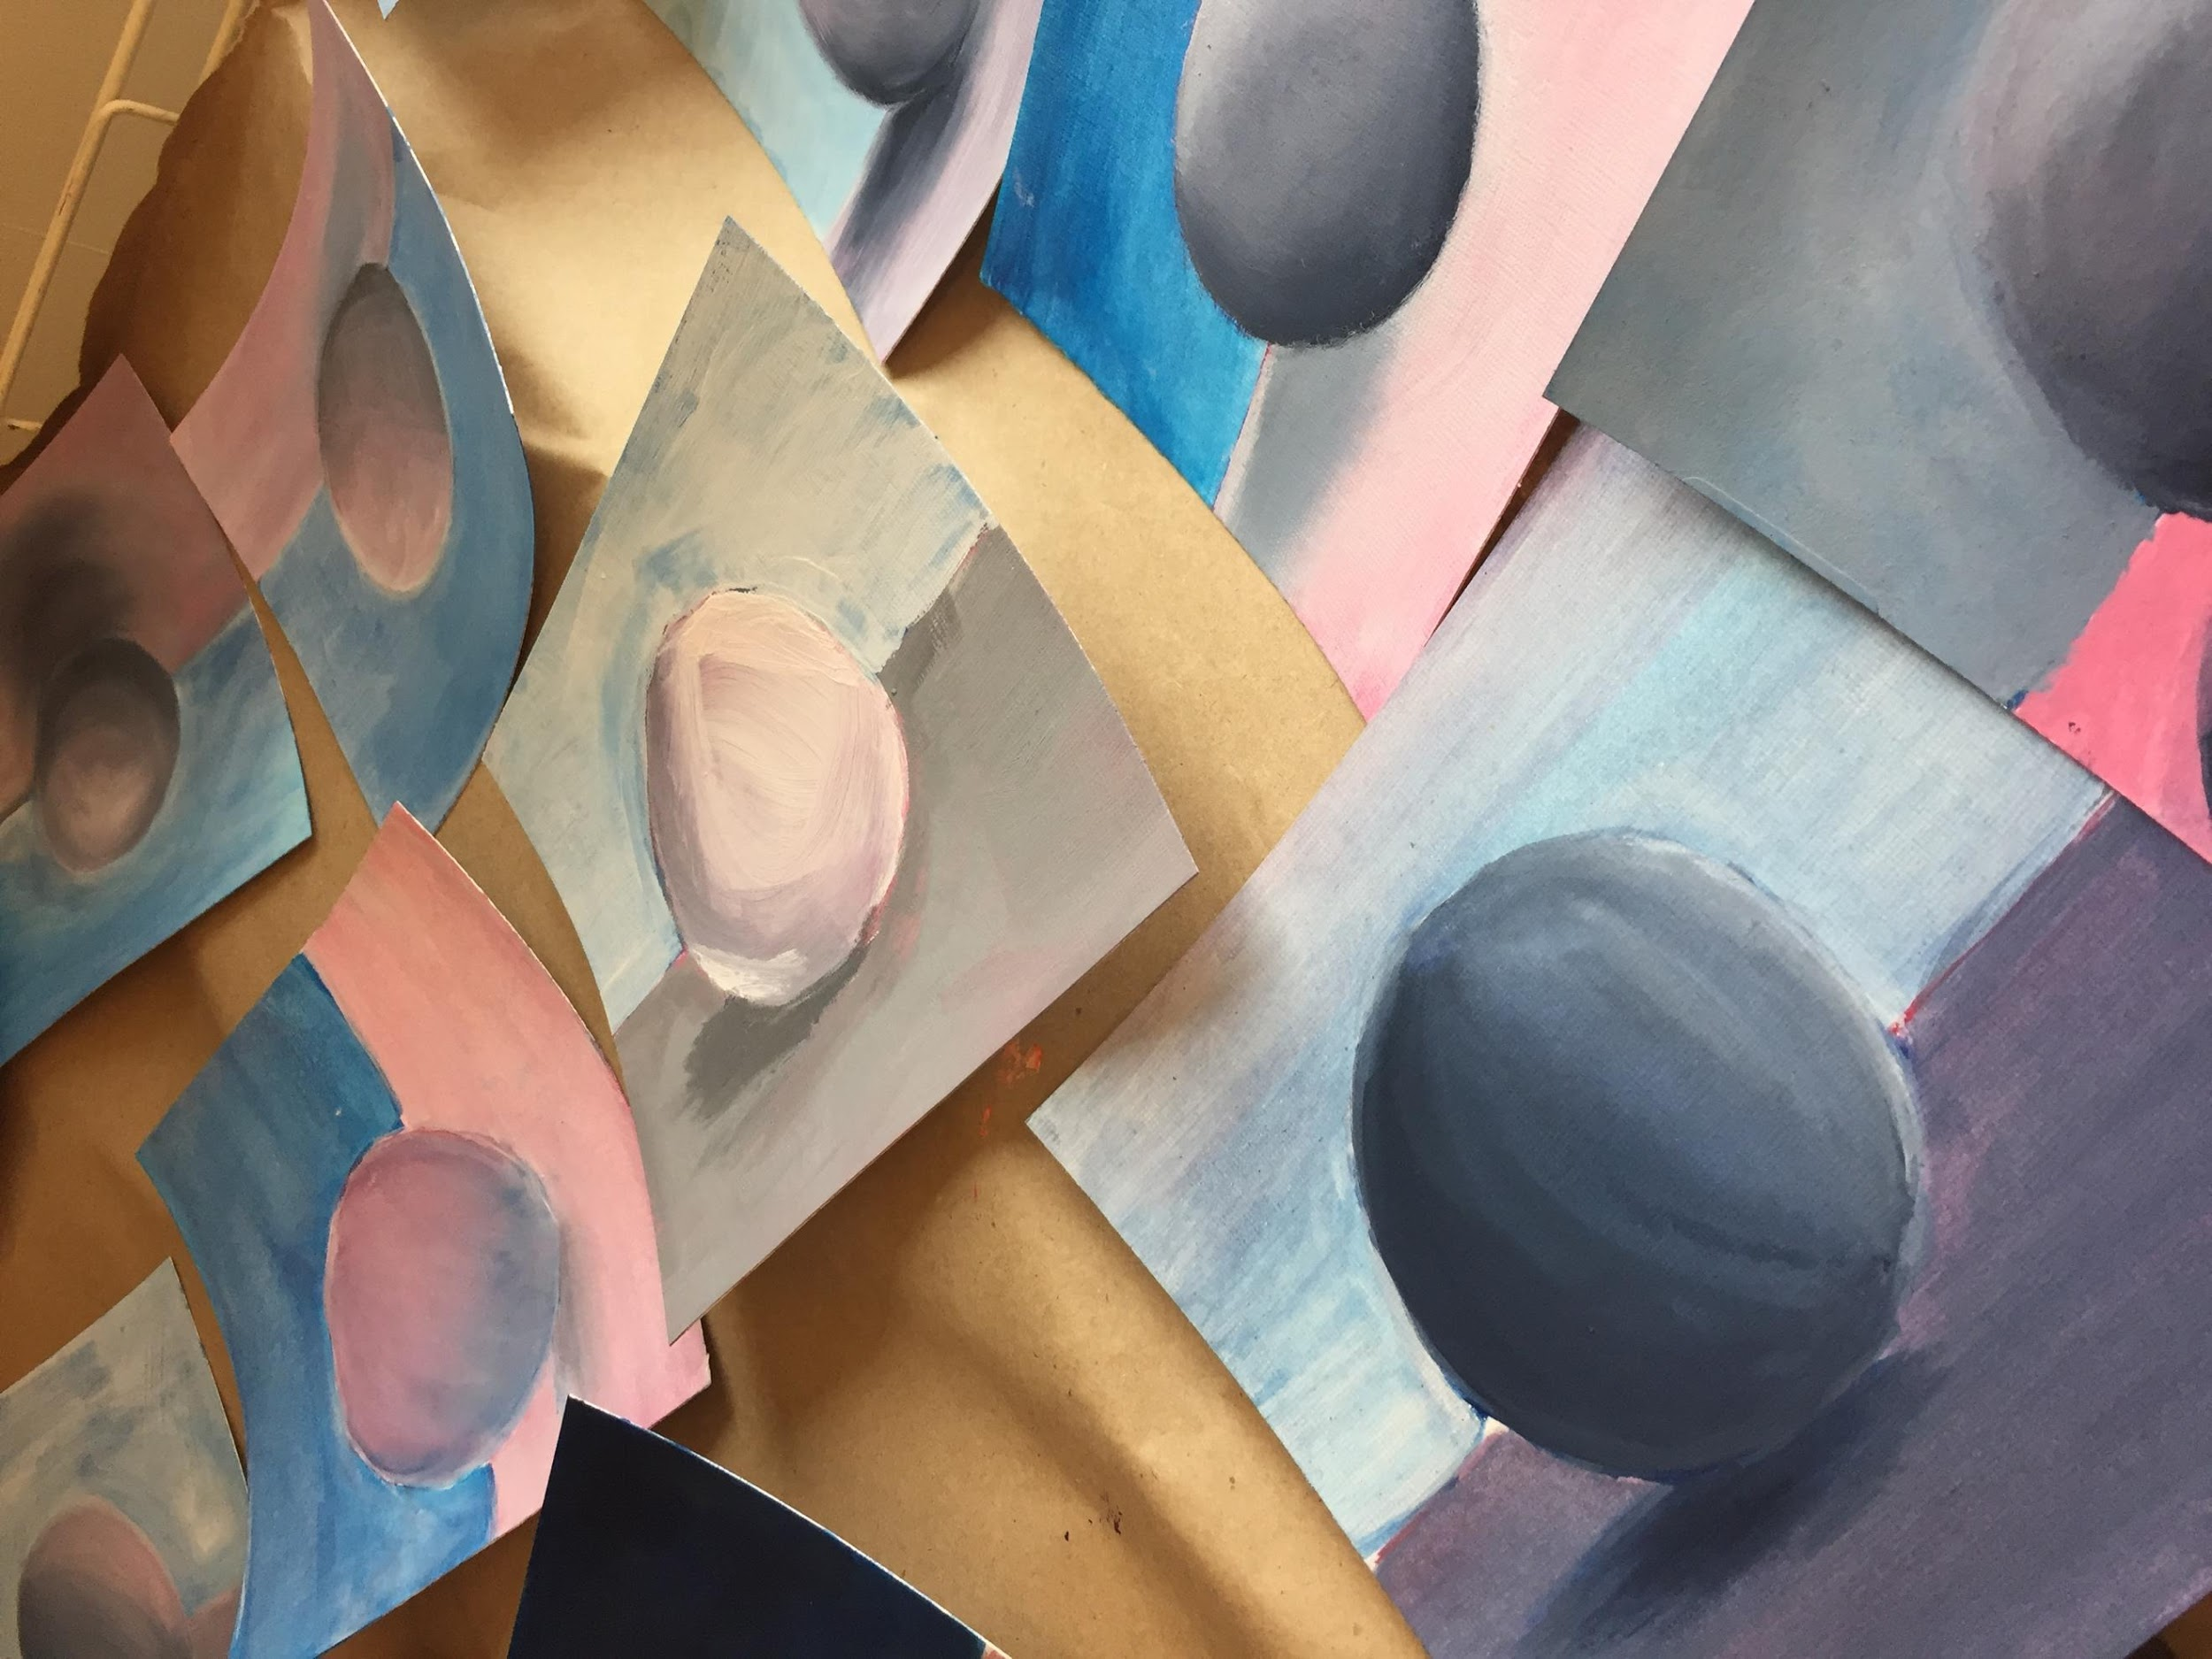
This exercise was tricky for some students and brought about frustration. I wonder if that felt unexpected for you. Is there anything you would have done differently? I overheard either you or Abbie reassure a student that was just an exercise, a practice for creating value, it doesn’t have to be a perfectly finished piece. This may have eased some of the tension of making it “perfect”. A few students accidentally started with blue instead of red- not a huge deal. However, at the end of your demo, especially if there are a lot of steps, feel free to ask the group something like: “When you get to your seat, what is the color you are going to start with?” This strategy may feel a little elementary school, but you can feel it out and see if it works with older classes when needed.

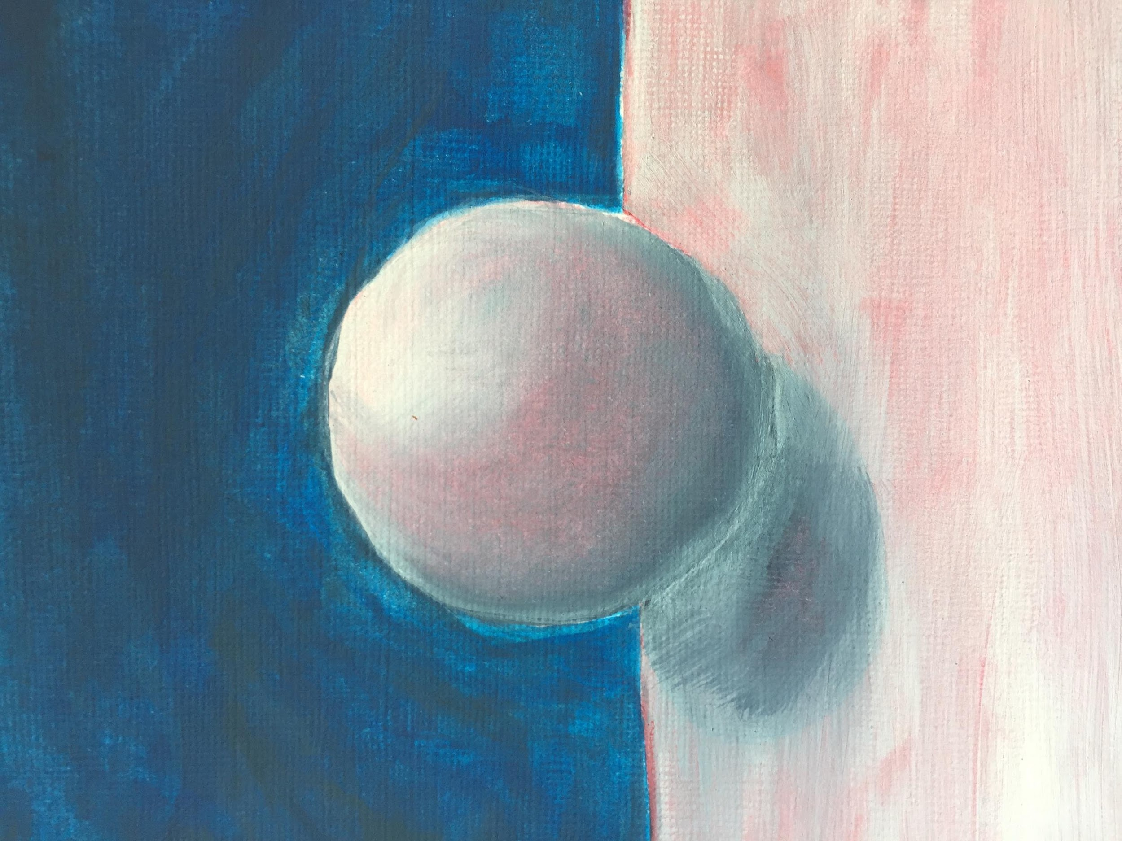
At around 1:10, when class was a little more than ½ over, you demonstrated using the white and black paint over the underpainting to finish the exercise and refine the painting. It seemed like some students were focused on your demo and some were glancing in the other direction or continuing to work on their underpainting. It is okay, you aren’t always going to have 100% attention from students all the time however, while you are doing a demonstration, it is a good idea to look around and make eye contact with students. There was one student who didn’t join the demo. I’m curious if you made the decision not to push this student to join you (they seemed to be having a bad day). As a teacher, you know which students to push and when to give some space. As long as it is a conscious decision, all good. I don’t know if this would have worked but… you could have moved your demo station over next to this student to include them.

Rachael, I can tell you are taking each experience you have in the classroom and learning from it. Your gentleness is really helpful when working with students who need a little extra love.

3/12/2020
Rachael Wells
CVU- Art 1
Putting Value & Texture to Work

“If you are doing your light values, use the HB pencil- just a reminder.”

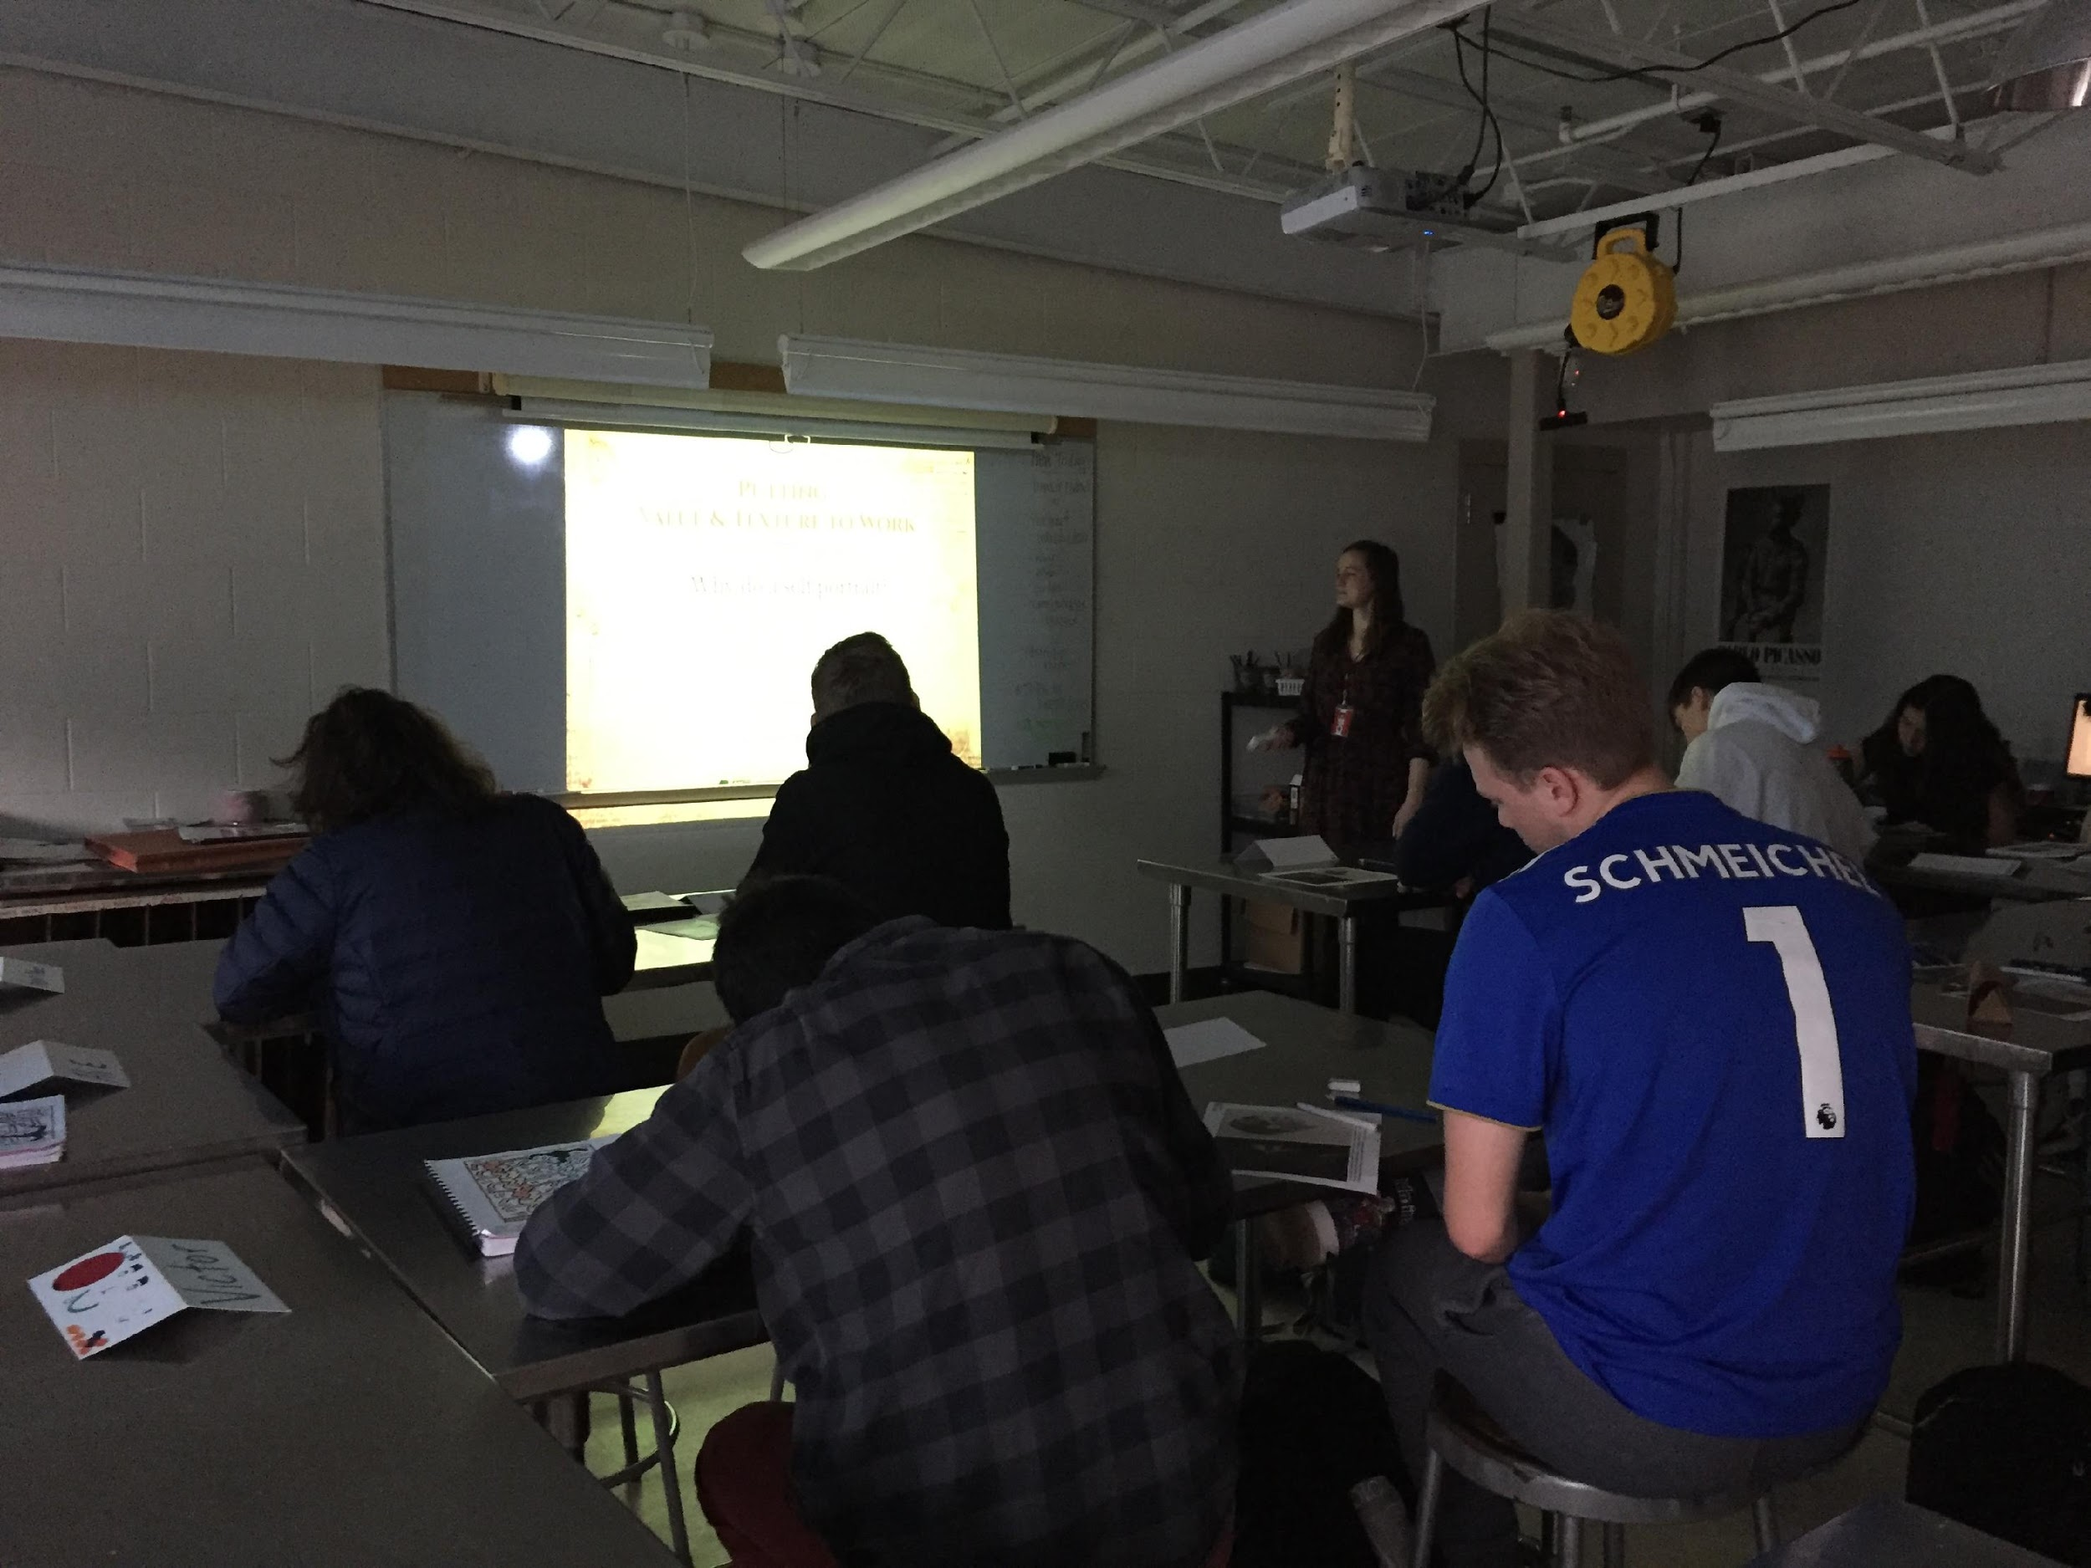

8:15 Students came into a well set up and organized classroom. Name cards and work was already set up on the tables and the board had the assignment posted. You greeted students, using an upbeat and welcoming voice.

8:25 All students are focused and working on shading their drawing. One student gets up and helps gathers supplies from the cart in the front of the room. There is virtually no talking. You are walking around, giving reminders.

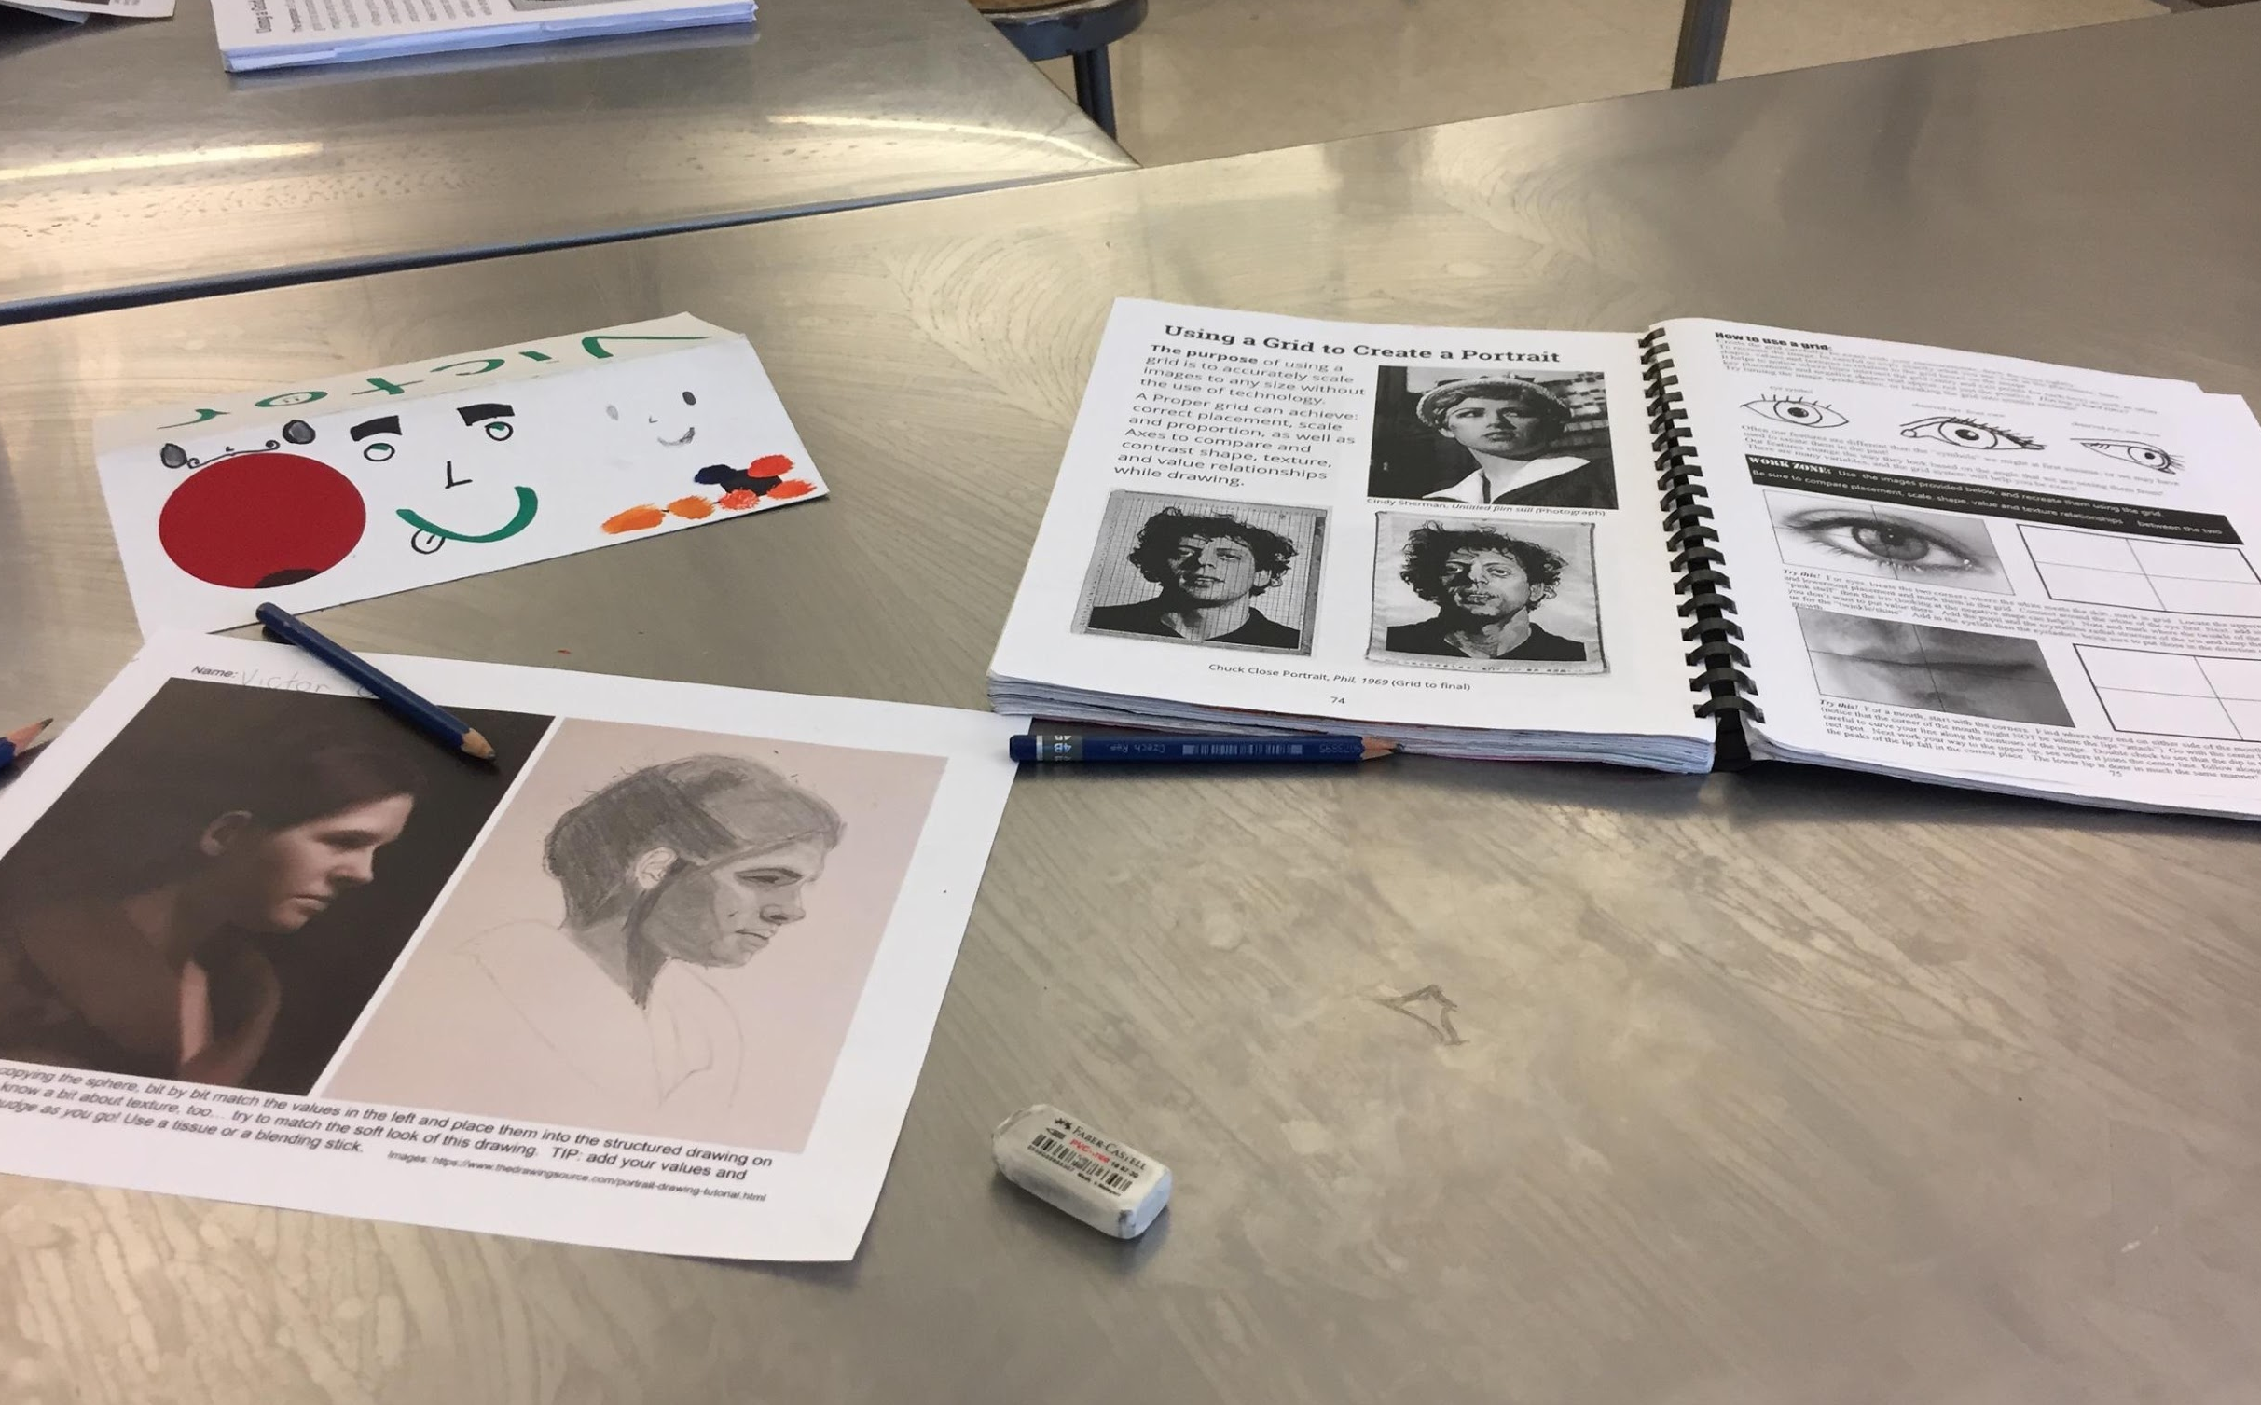

8:30 Wrapping up shading worksheet. You let students know to wrap it up. Many start working faster- they don’t seem to want to stop. You dim the lights- “I know it’s so fun, isn’t it!” You try and get the student’s attention. Most keep working.

“Why would we do a self-portrait?” You stated with this question- one student answered that it would be on the summative. You stated a few other reasons- including it was fun!

Demo: Image below. Also see video footage

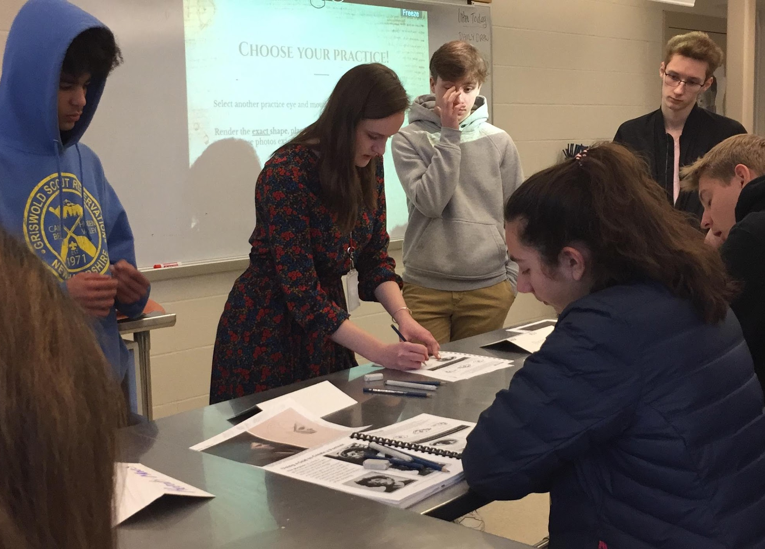

8:45 Demo ends- students head back to their seat to draw the basic shapes of the eye and lip in their sketch book.

8:52 All students focused and working in their sketch book, drawing the eye and lip shape, using the grid… You are looking around, giving a few reminders. One student pushes his sketch book in front of another student to show off his work and then says “I don’t know what to do now.”

8:54 Student comes in late with a pass. You get them settled in. You also announce you will give everyone two more minutes. The students who are comparing work talk about how their eye looks too big.

8:56 “I want to show everyone what the next thing is. Almost everyone is finished or almost finished.” “Can we put our pencils down, we can revisit this afterword.”

8:57 Students gather- you make sure everyone can see. You begin the shading demo- the nose. “If I think my values are too dark in a place, I can go in and take away some of the value with my eraser.”
“Oh, I forgot something! “
“What did I forget?”
Student replies, “the nostrils.”
“What do I need in the nostrils, Ray?”

9:04 Students return to their seats to continue working in their sketch books, now working on the nose. If they finish they can go back and work on the eye.

9:05 You and your mentor teacher talked for a moment.
9:06 “I apologize if I wasn’t super clear.” You went back to explain that students should finish the basic shapes page first before they go into the value page. You talked about the importance of doing a basic shape first, even when they move onto value.

9:10 As you are walking around you stop and work with the student who came in a few minutes ago. You demonstrate for this student what you demonstrated to the whole group.

Students are focused and working. Some light talking- with humor- someone says something about kissable lips. Some students feel proud and want to show their work.

9:15 You sit with a student and I see he says something to you- you smile and say, “Oh, you are kind of a perfectionist” Then I observe you ask the student a few questions to guide him- he does something in his sketch book and you encourage him, “nice!” You continue to point out how to see things and translate that information to the drawing. You continue to use questions to guide, “what happens to the nostrils when you….?” “We are making progress, look at us!”

9:17 Abby (mentor teacher) consults with you- maybe about timing?

9:19 You move away from helping that students.

The students in front of me help each other. “I think if you do this…”

You stop at other students to check in.

Rachael Wells
January 28, 2020
CVU
Painting- Advanced Painting (4 students) and Painting combined

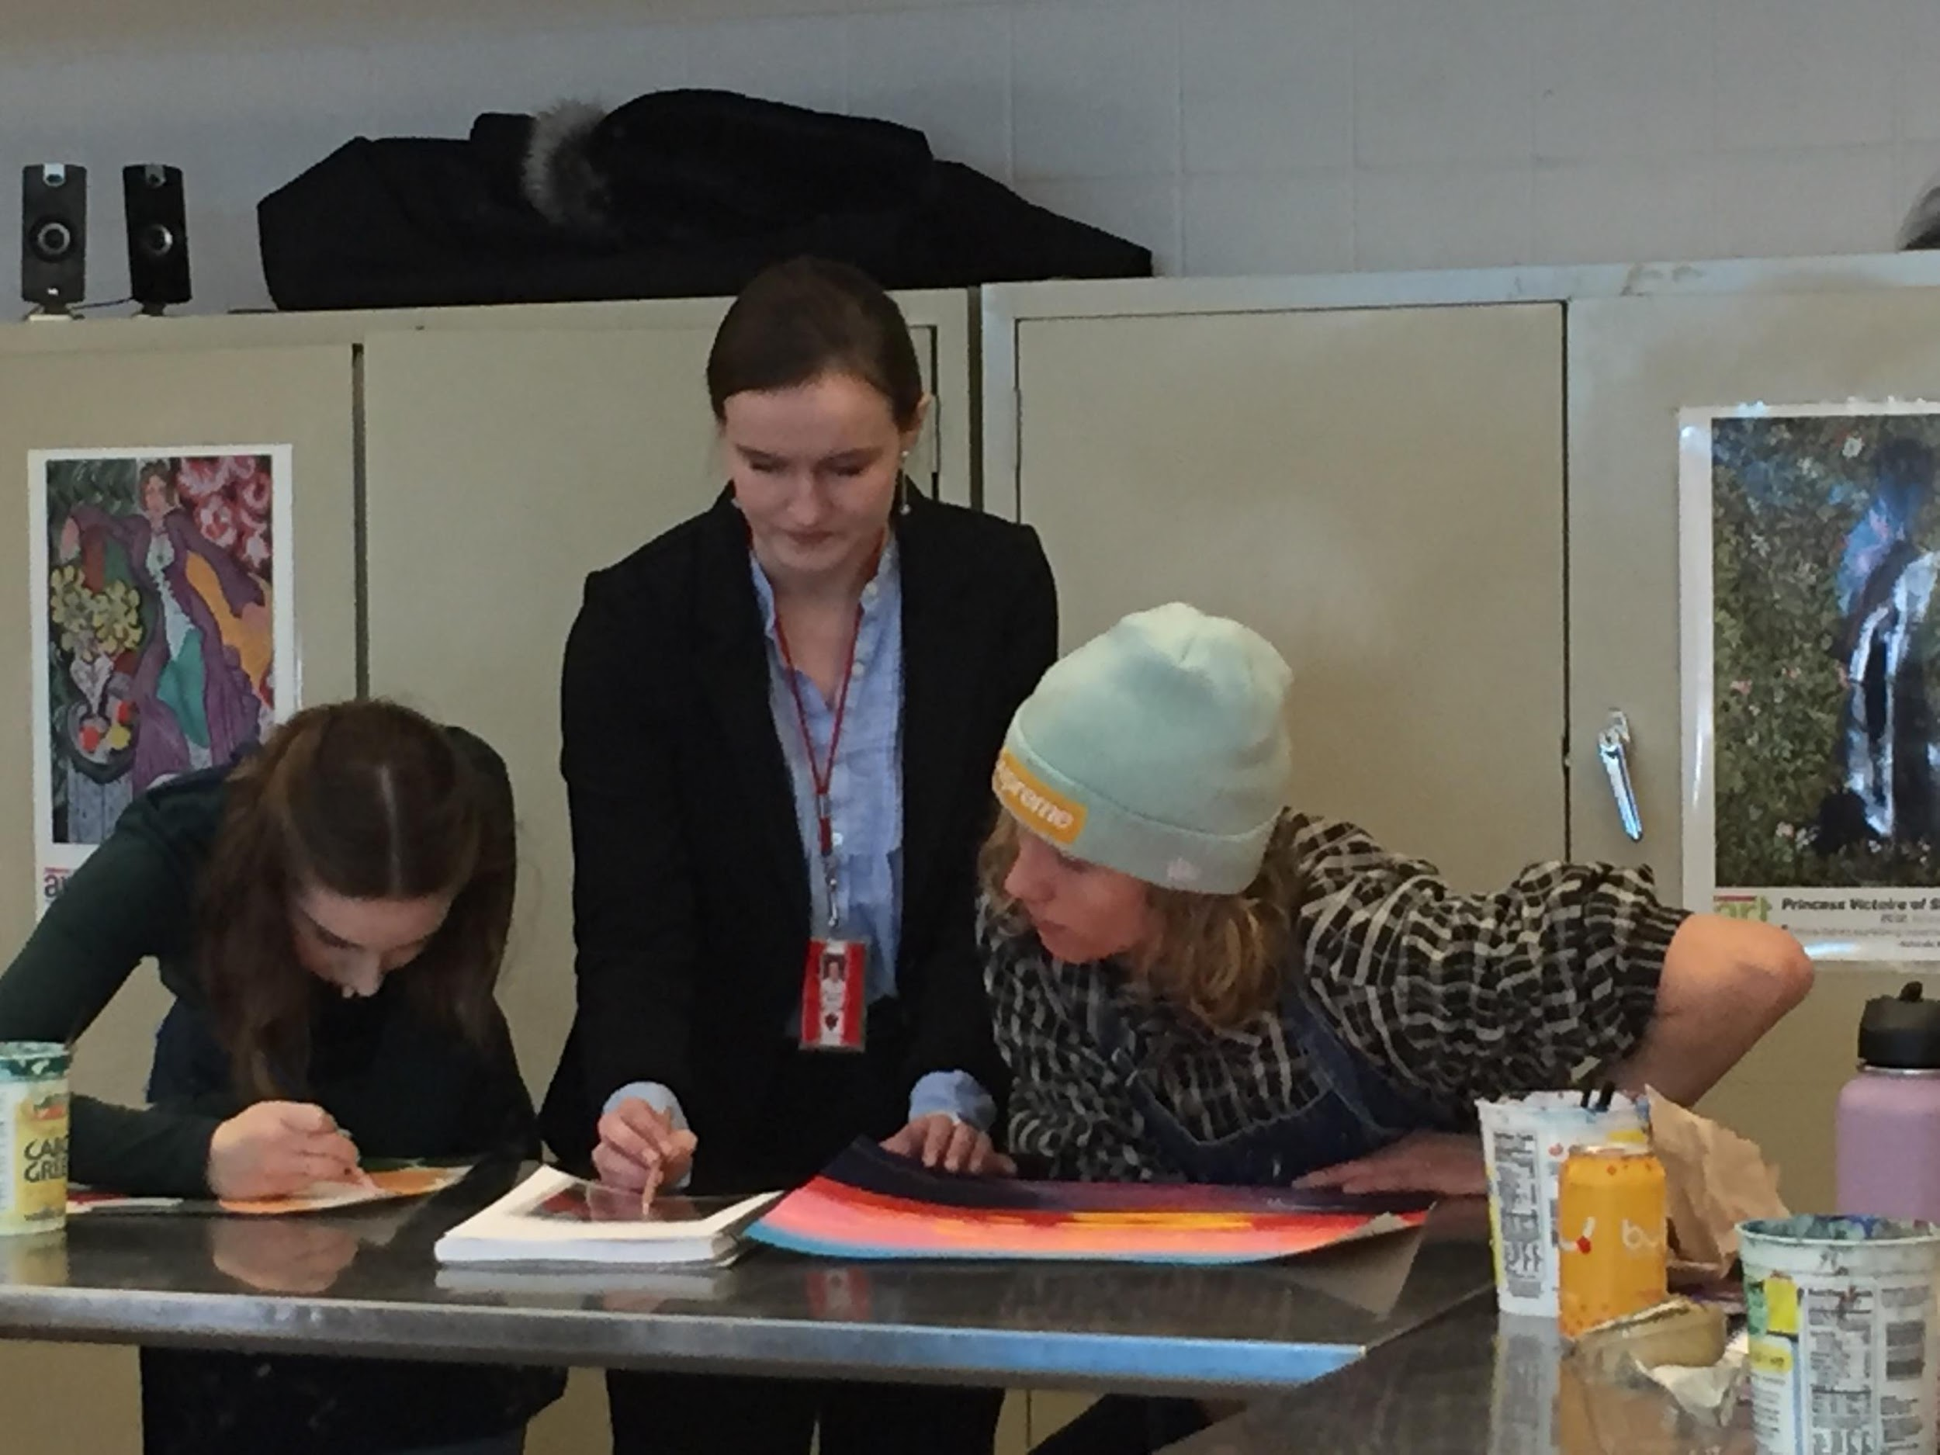
Today the painting class was working on a project where they were creating a painting from a collage the assembled in a previous class. This is a class that you are building responsibility and leadership with. When I first arrived, you were working alongside a student who needed to catch up. By reading your posture and body language, I could tell that you were confident in your roll of leading the class. After getting the student off on the right start you moved around the room to check in with students. Your demeanor was kind, professional, and open. It was great that you appeared to comfortable engaging with your students. Sometimes it can be difficult to approach students and sense if they want help or to be left alone. This did not seem to be a problem for you at all. And students really enjoyed having your feedback.
Today I noticed you:
- used questioning to encourage students to reflect on their own work
  - “Where do you want your focal point to be?”
  - “What color do you think that should be?”
  - “Oh! Did you add green to that?”
  - “What do you see? Black or dark brown?”
  - “Are you going for a solid look or more of a wash?”
- put students at ease with your smile and joyful laugh
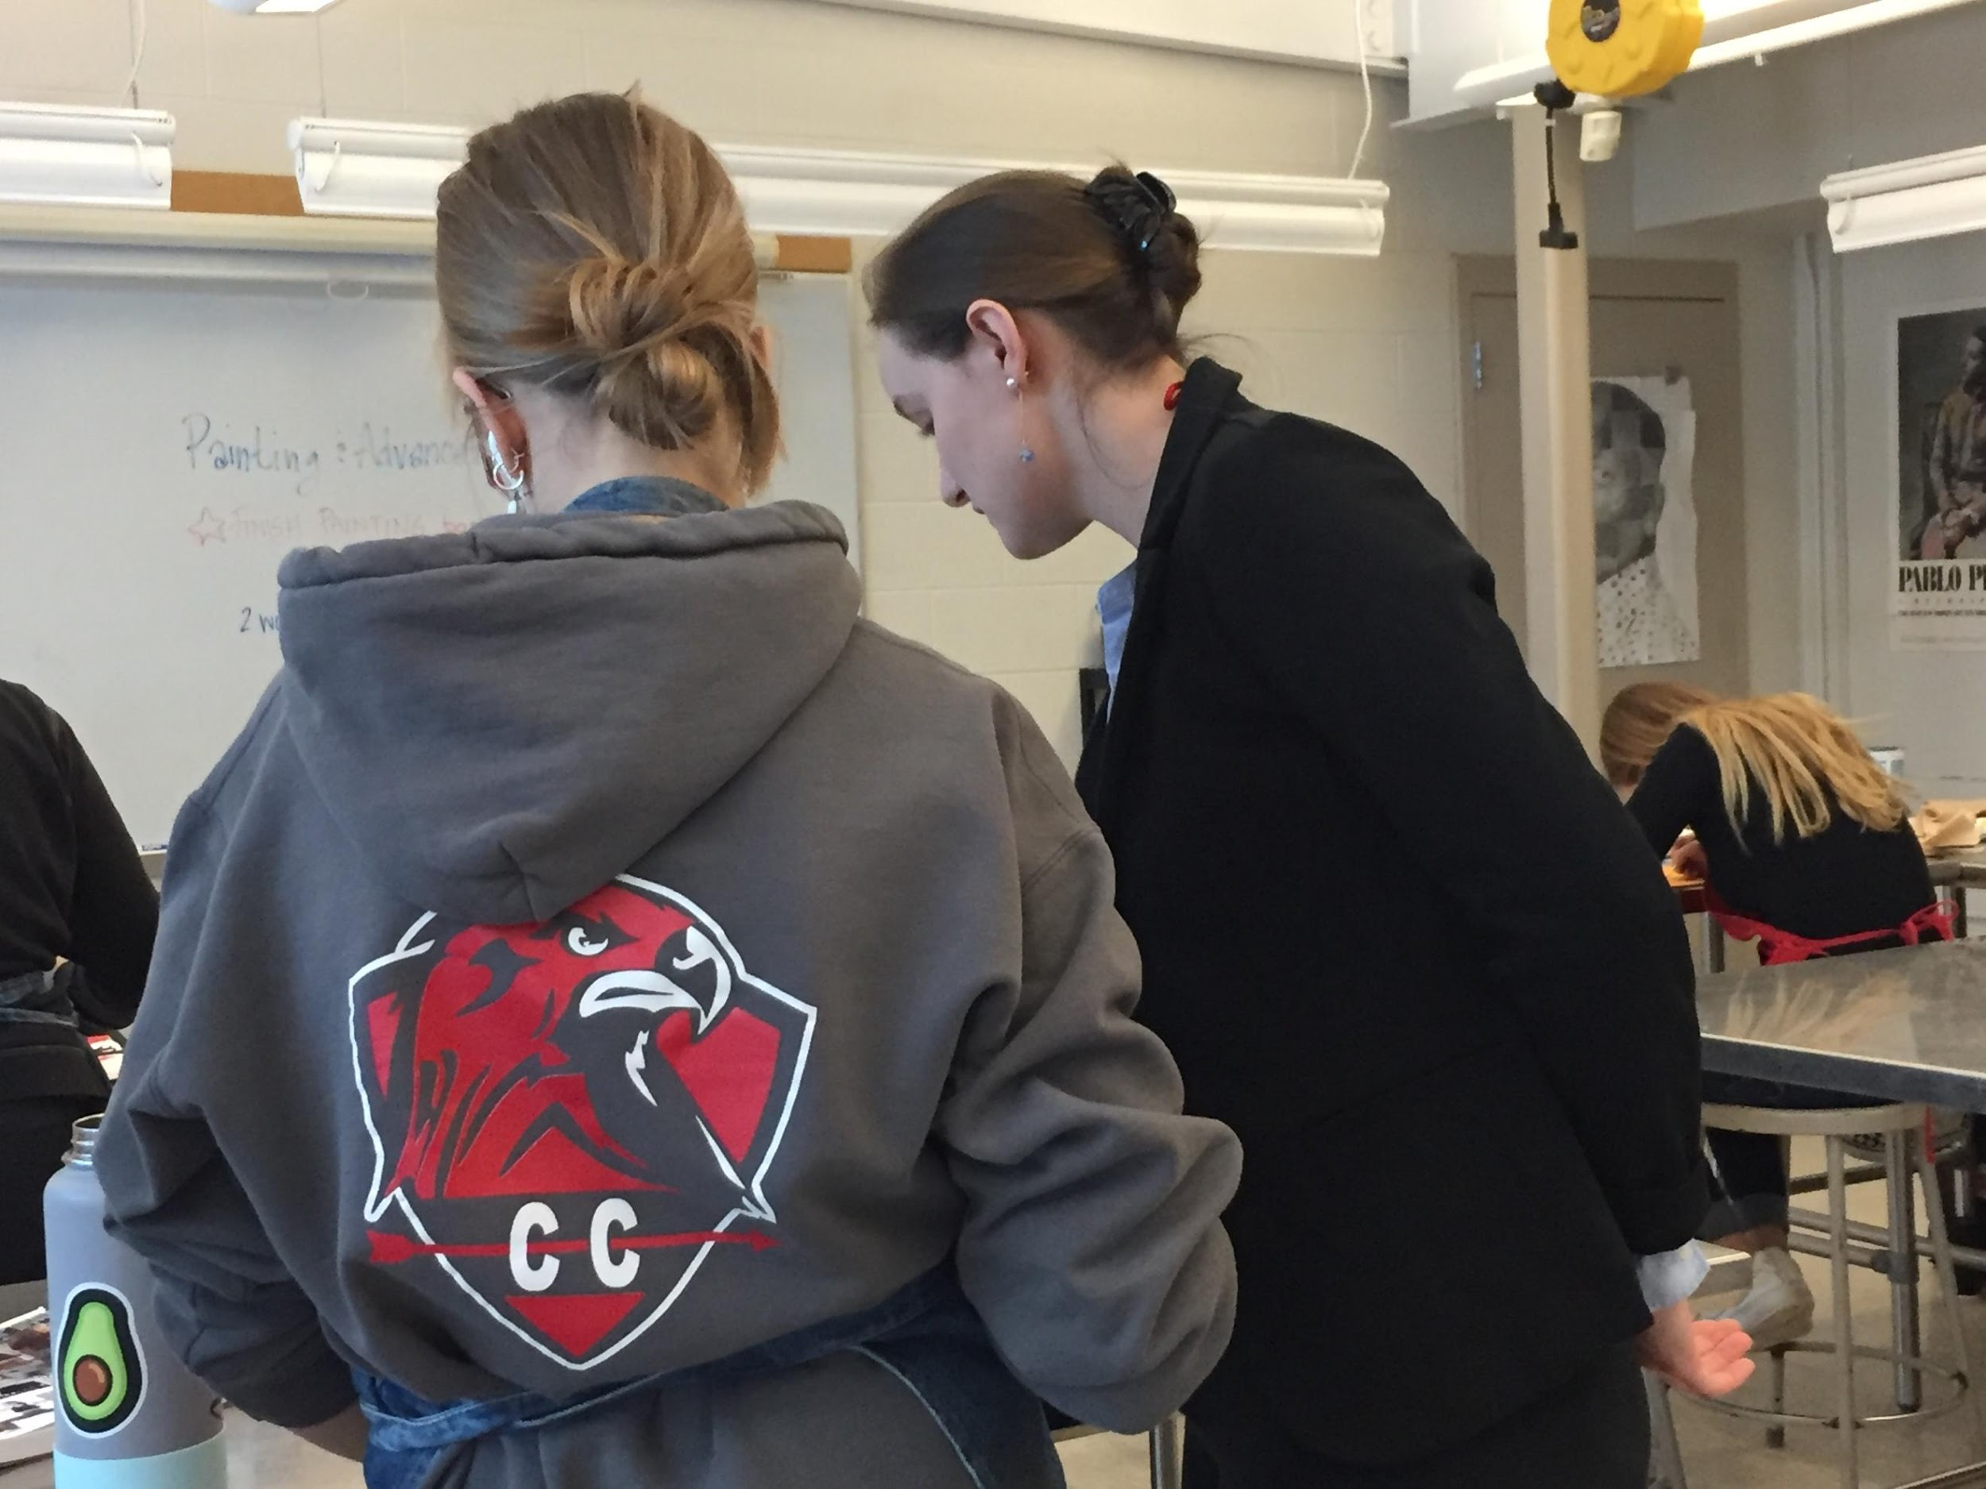
- demonstrated your content knowledge (painting) by offering individualized instruction/feedback in paint application, color mixing, composition, finding shapes…
- Centering your students’ needs, goals, and vision (see questions- you are seeking information from student before jumping in with “help”)
Things to think about:
- “working the room” making sure to keep looking around – This is also what I call, “developing eyes in the back of your head”.
- Noting the student who will need more support before they come in (look at their work in progress before class) and preparing to set them up for success

Great work Rachael!

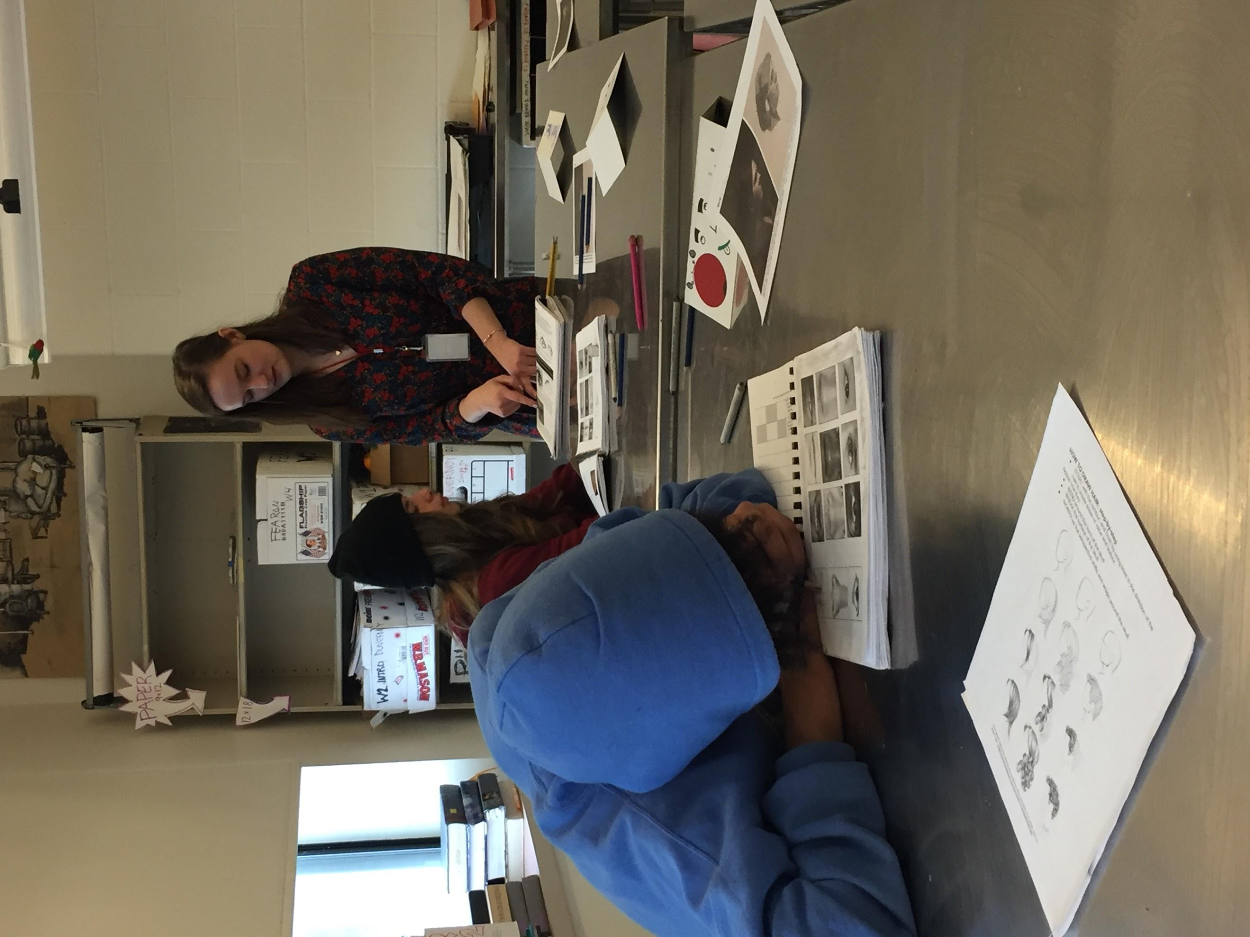

9:25 A few students on their phones. A bit more chatting. Class has been going on for over an hour now- maybe it is harder for students to focus now?

Majority still really focused. A few students sitting near each other show their work and talk about it.

9:35 Work continues. You talk to the whole group: “Something that I just got from one of our peers…..one little tip” (about blending tool). You remind students that they will be handing in their sketch books at the end of class today but it isn’t time to pack up yet.

9:43 Some students are standing up/packing up. A few are talking about sports, etc. You are talking with the student who came in late- explaining the assignments and looking over their sketch book.

9:44 You give an announcement. Turn in your sketch books for the end of the quarter- week. Hair homework and “shady lady” also to be turned in.

9:45 Bell rings, students hand in work, ask a few questions. “I didn’t finish the hair” You- “That’s ok but you still need to hand it in.”

Notes/Reminders:

Your content knowledge is strong and you are able to explain concepts and address misconceptions in understandable ways.

Your interactions with students are well received. You are warm and encouraging.

I encourage you to continue to work on and think about the flow of the class- the speed and pace on demonstrations.

*We are at (slightly past) the midpoint. Please fill out the art ed checklist assessment as a self-assessment on TK-20

This is a worksheet that I made for my students in intro to art to practice their brush control.

