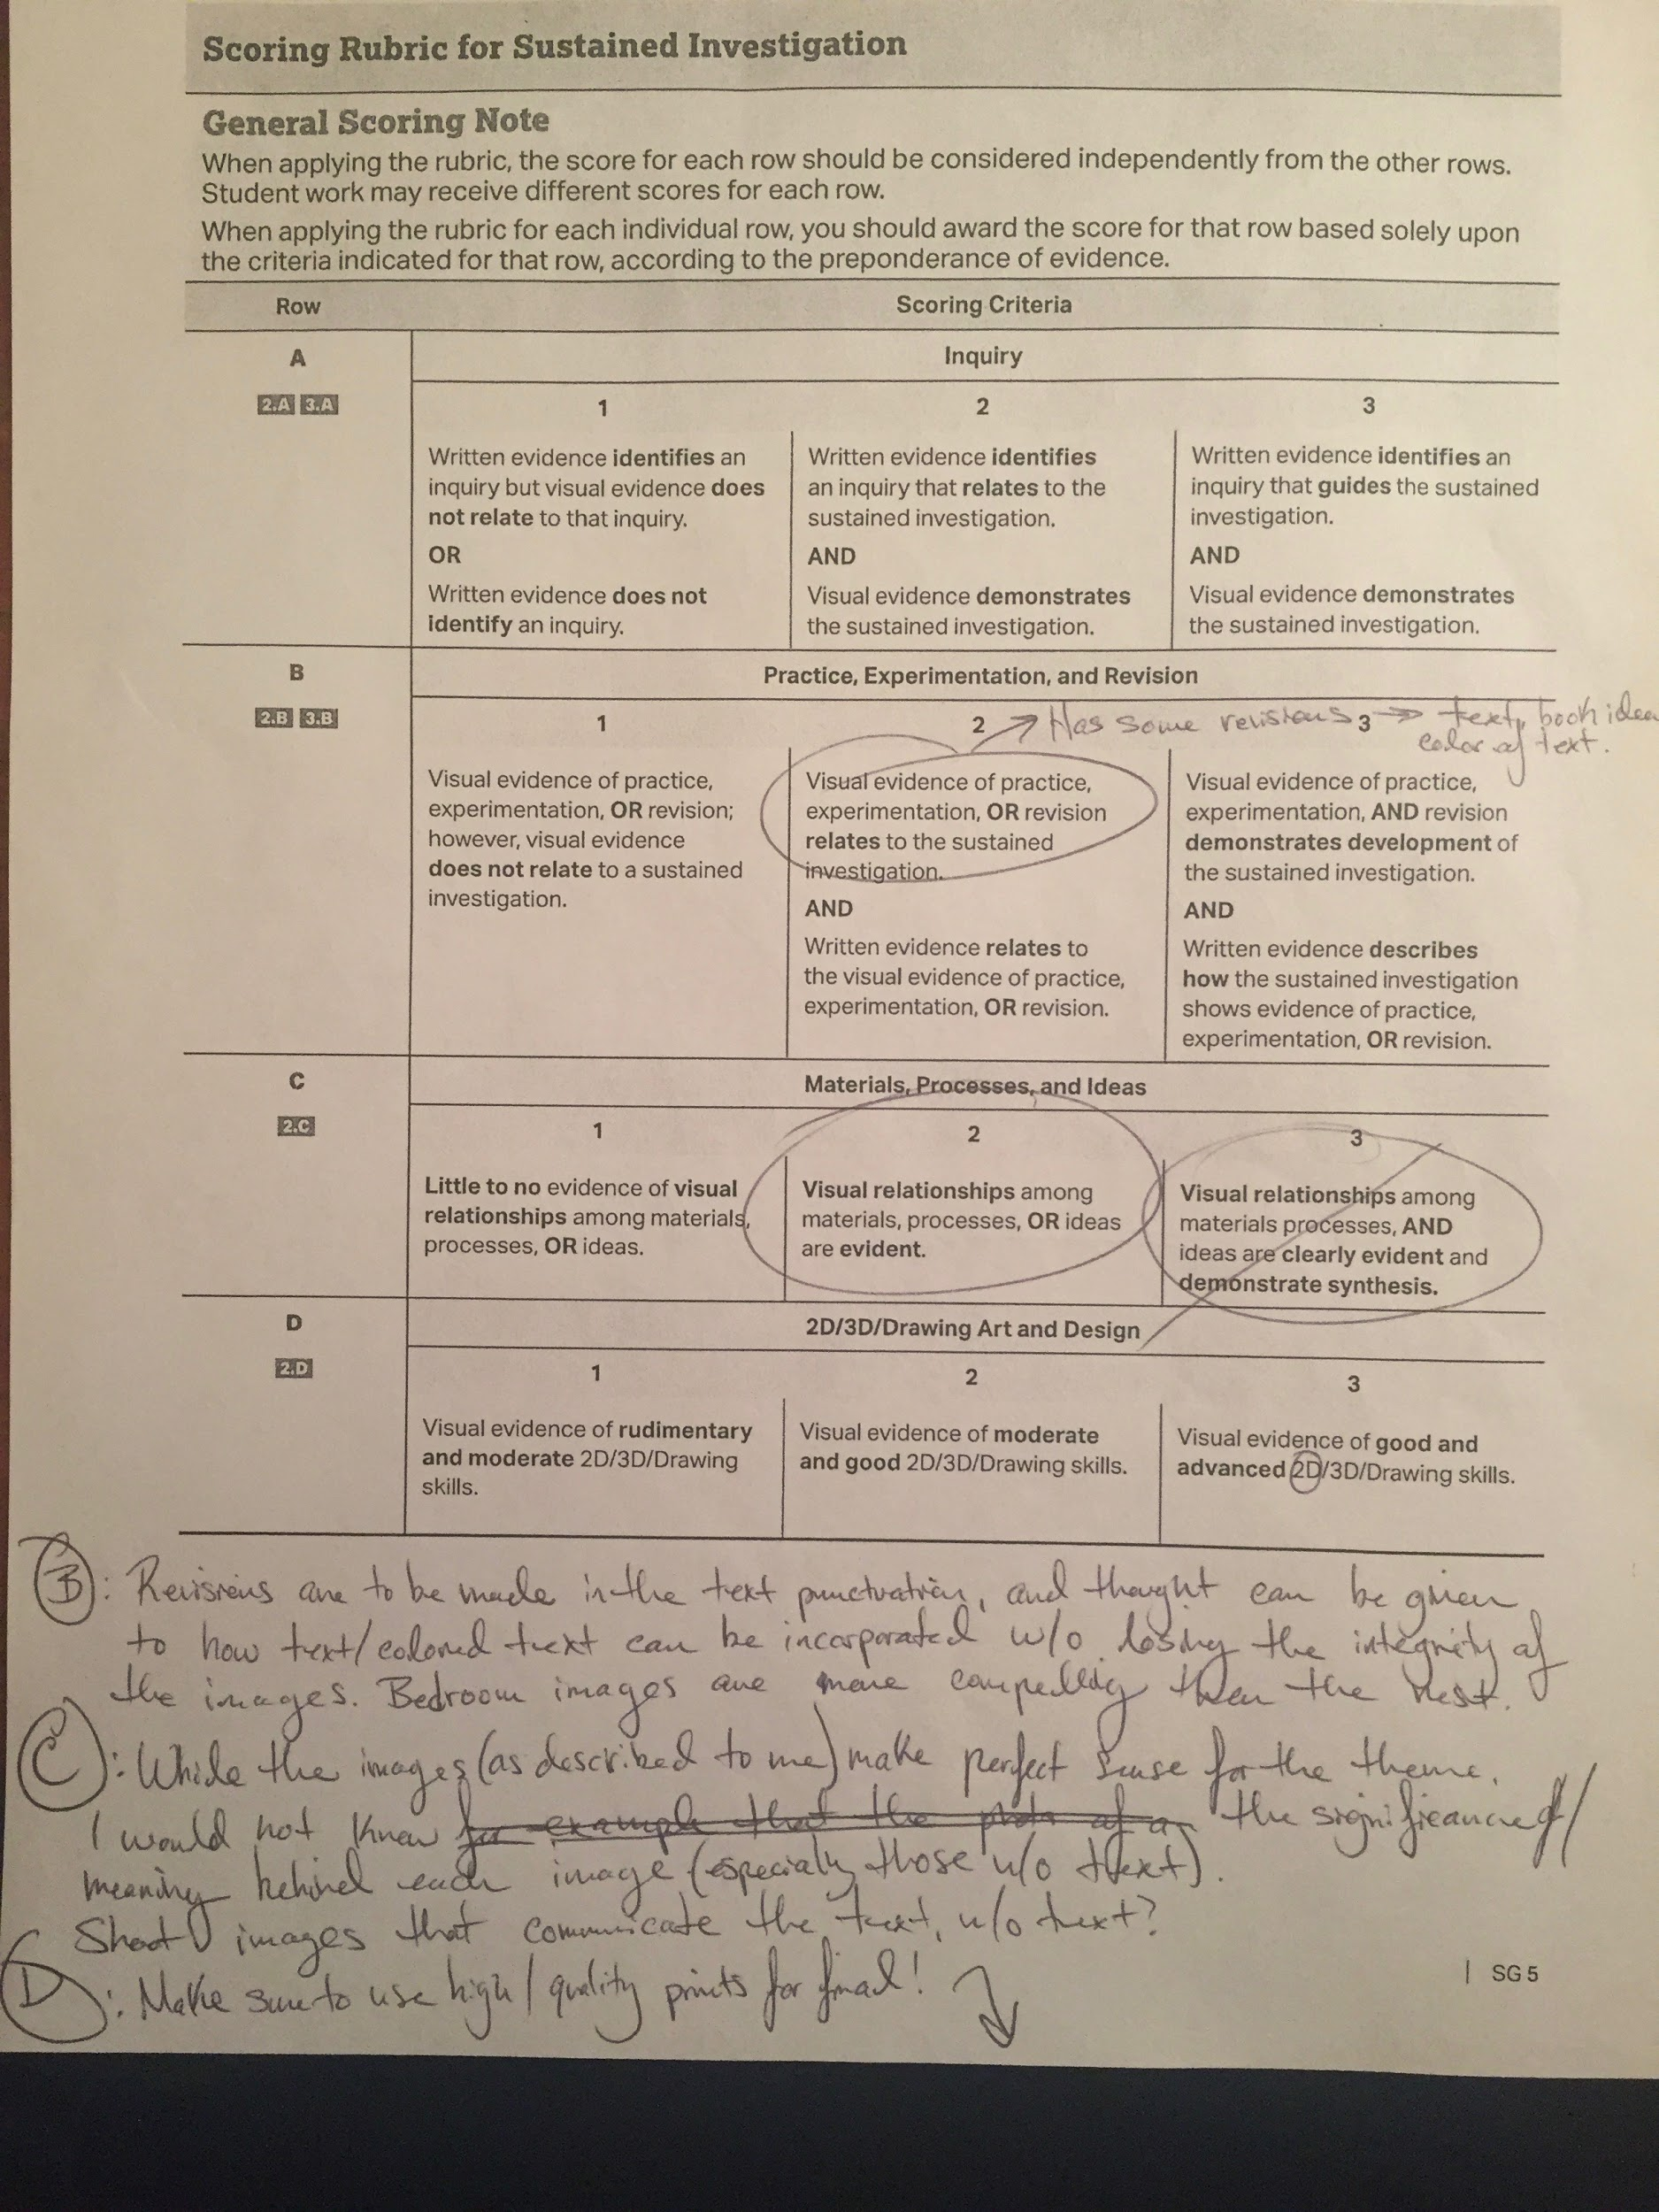

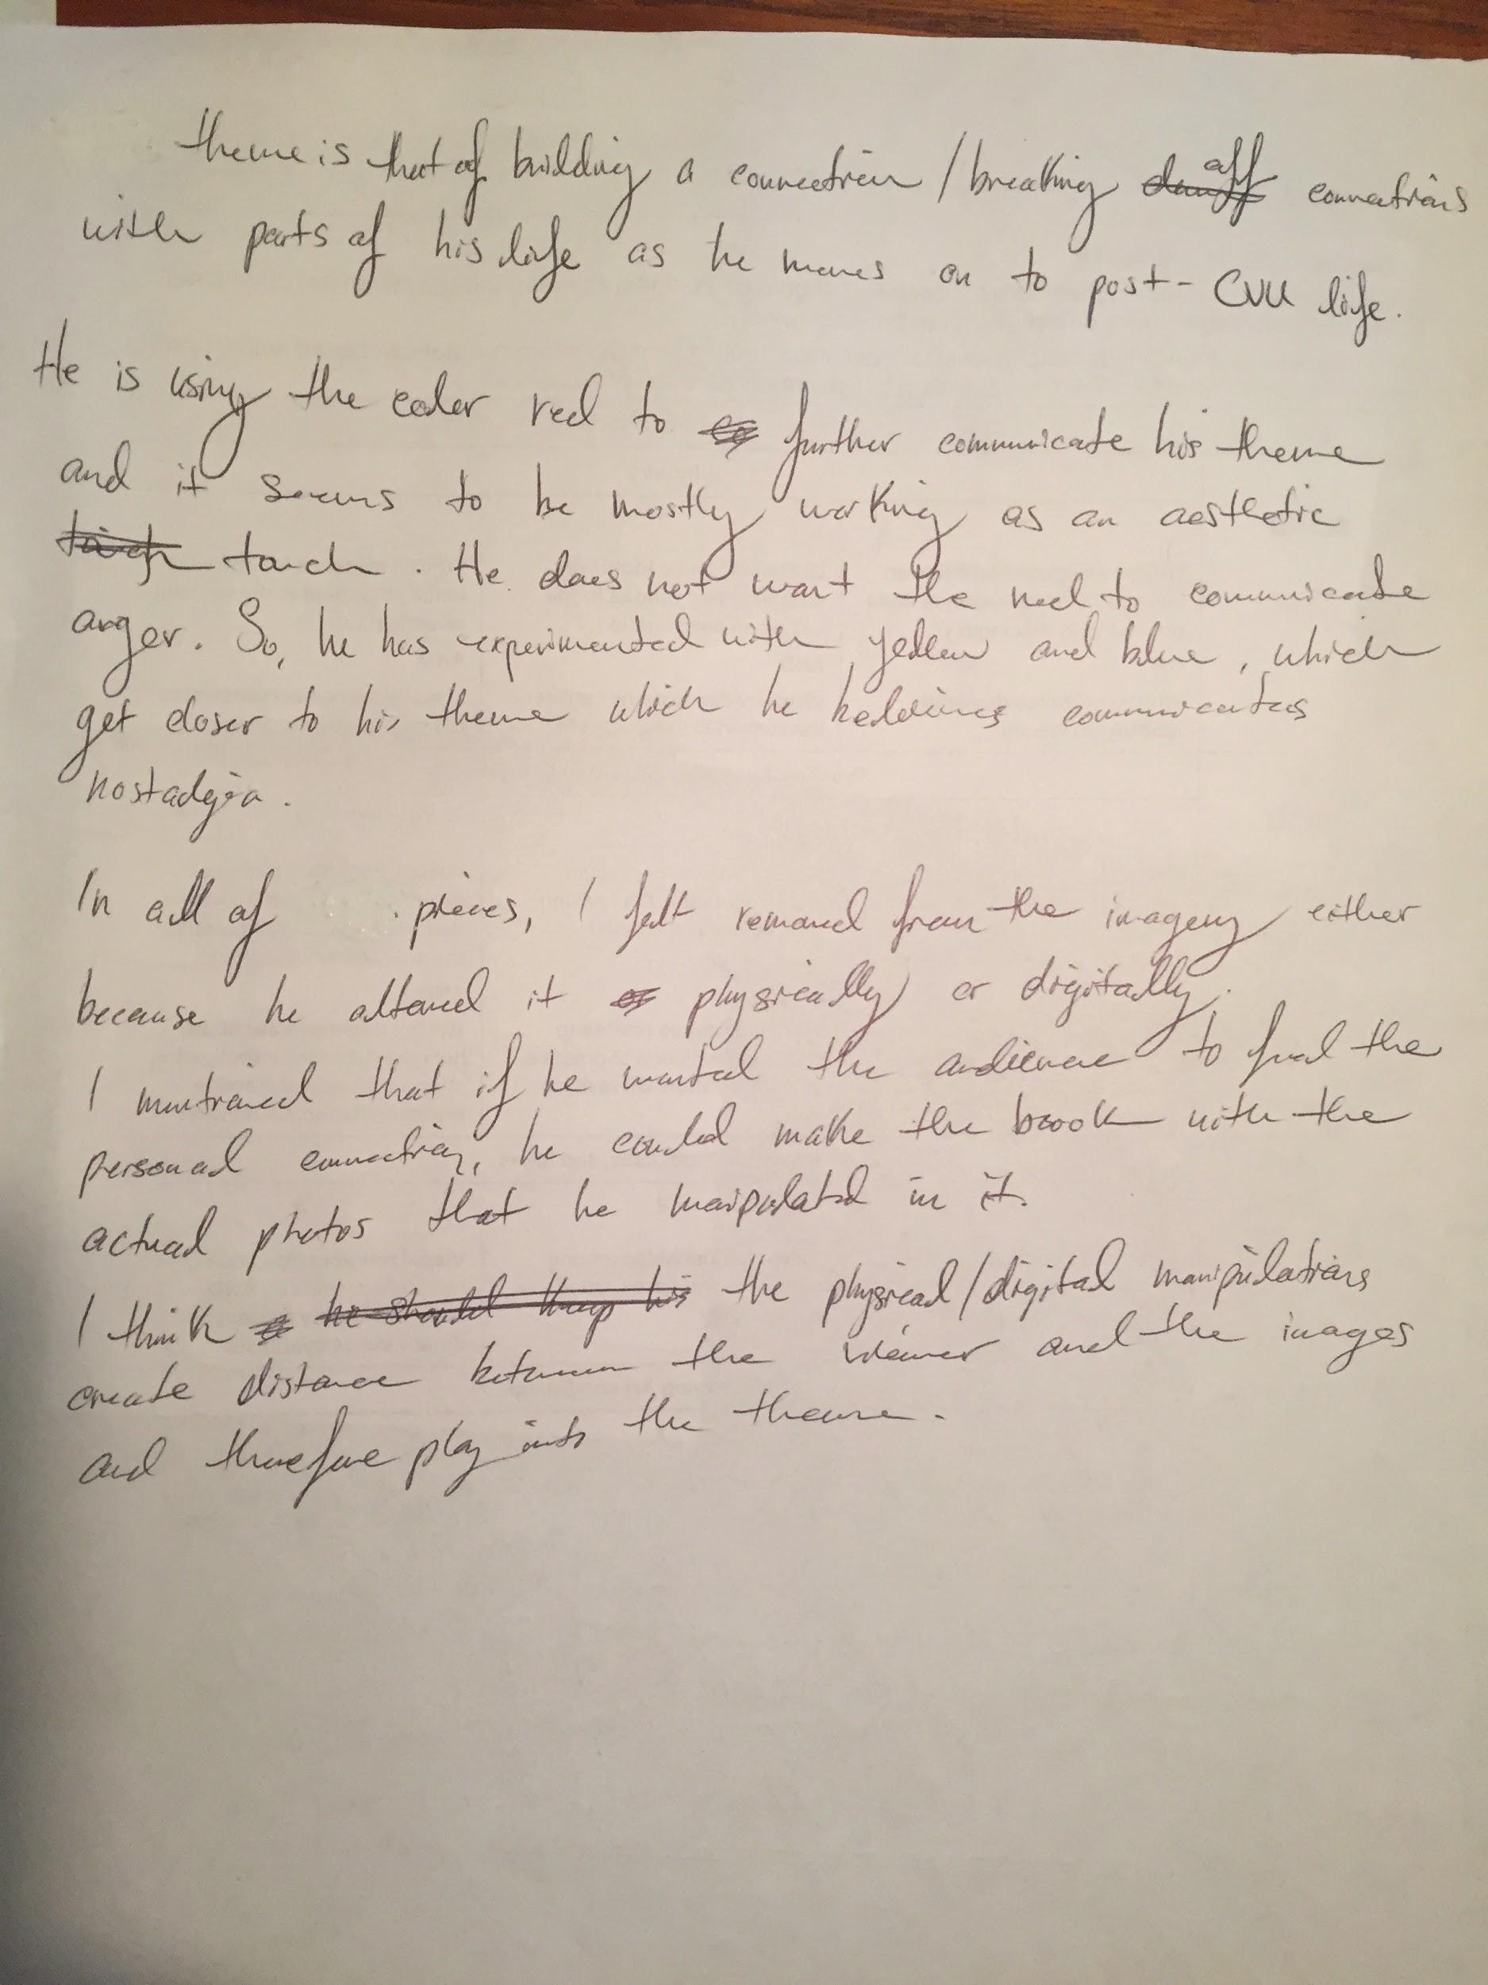

Above is an image of the critique rubric that I filled out for one of the students that I had for the AP Art critique. The value in me doing this with students for the first time is that it brought me out of my current comfort zone with the students I had been working with as a student teacher, and allowed me to experience another realm of giving feedback that is most commonly used in AP art classes. I would like to teach AP Art one day, and I believe this event helped me see more of what an AP Art class looks like and what it feels like to be an AP Art teacher, even with just the assessment and feedback part of the job. Although I was already involved with a full workload of student teaching, I went out of my way to be involved in this professional learning opportunity.

Evidence #2 is on the following pages...

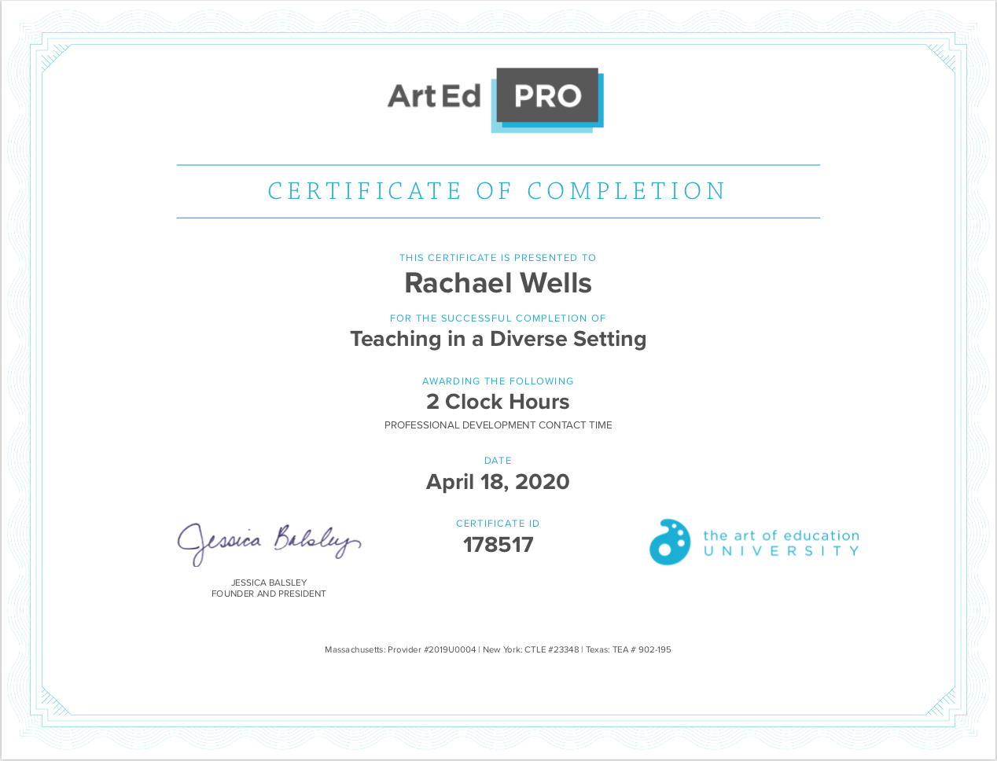
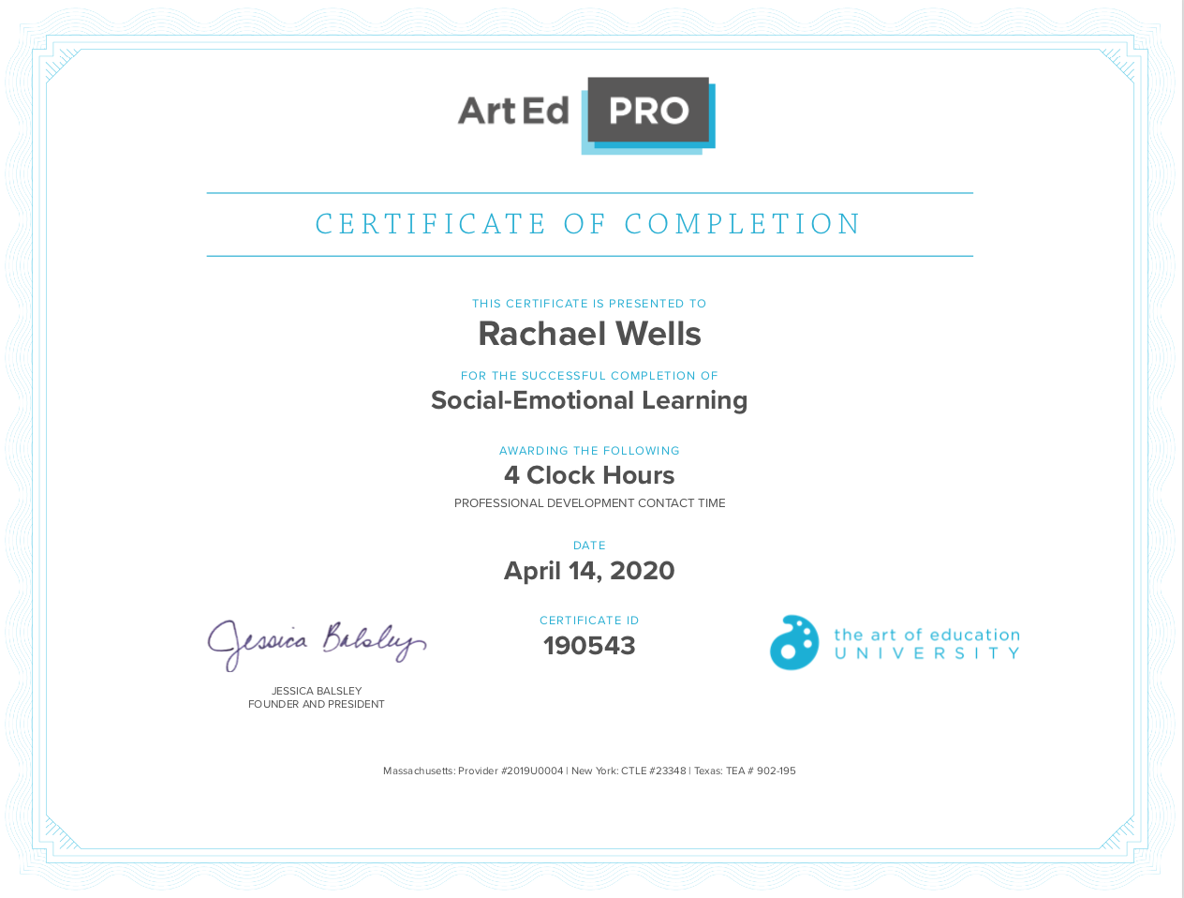
I completed these two modules after student teaching to continue my learning in the areas of SEL and teaching in a diverse setting. I wanted to learn more about SEL because I believe it is a very important and useful foundation from which successful classes come from. I wanted to then learn more about teaching in a diverse setting because while my student teaching site was a wonderful placement, and I learned a lot, it does not have as diverse a population as other schools I’ve been in.

In the Social Emotional Learning module, I found that the art room is actually a great place to develop and maintain a routine and methods in SEL because of the accessibility to projects that students get excited about and the power of sharing images. This module was focused more on elementary school methods than high school methods. However, there were some ideas that I can see are easily applicable to a high school classroom. Involving administrative staff in classroom activities to improve that relationship therefore decreasing stress, practicing breathing techniques such as the square breath of the triangle breath, creating lessons that are based on self-reflection, collaboration and SEL outreach, and having classroom or Restorative Practice circles, showing examples of famous artwork that show emotion, therefore showing that it is ok and encouraged to express emotions in artwork, and even simple things like seating in table groups rather than individual tables are methods of SEL that can apply to all ages of learners. SEL is about bringing a class and the community/staff that support them together. This is done through active engagement in sharing each other's thoughts and work, with the goal to empower students, giving them the confidence and skills to regulate their emotions and build and maintain relationships.

I have also completed the "Teaching in Diverse Settings" module. I learned about how to engage with learners in a setting where you really have to educate yourself about your learners. This could be, for example, in a high school setting with a yearly or semesterly turn-over of students. Some ways to be more successful with your students is to observe other teachers. A tip this module instructor has is to talk to the teacher before observing their class to see what their goals are, so that when you're observing you can see how that teacher gets the class to the goal(s) that they have for that day, depending on what happens in the class period. I also learned about how to build positive and supportive relationships with students, and got some tips on how to make the art classroom a safe place for learners. There were also some really great lesson ideas at the end that I want to use in the future that allow students to dig deeper into their thoughts and beliefs and develop ways to cope with concepts such as fear by showing their emotions in their work. One of the lessons was a comic lesson and the instructor talked about how some of the kids in her class expressed that they had a harder time making a visual story than following a visual story. The instructor accommodated them by allowing them to use a story they're familiar with and building off of it in their own comic. There were some students who were more confident in writing their comics in Spanish, and another student who was bilingual in english and Spanish translated the comic for other students to understand it. Other students were more comfortable not having text in their comics at all because they were not as confident in writing, so the teacher worked with them to develop a comic that communicated with imagery alone, using body language and framing. Overall, this module was very interesting and it covered a lot more than I've mentioned here. I'm glad I chose it.

