Evidence #1: This is what my mentor teacher and I called the “Portfolio Keeper.”
After each unit in Intro to Art, students would upload a series of images that they believed contributed to their growth in different disciplines. This is from one student’s submission for the Line Unit.
All work for this class was either done in the sketchbook or was put into the sketchbook, and I was able to collect sketchbooks often to see how students were progressing and to give them feedback.

LINE SECTION:
Selected Sketchbook Entry: | Describe how this activity moved you forward in our class and / or toward your learning goal | Title, Media, Month/Year, Size of artwork | Well lit, not distorted, focused & cropped image of the work:
Daily Draw Exploratories | It helped me to learn how to draw more realistically by drawing all the edges  It helped me to learn how to draw more realistically by drawing all the edges  It gave me de idea of how to create volume in 2D  It helped me consider each line as an element of the artwork | February, Full Page  February, Full Page  February, Full Page  February, Full Page | 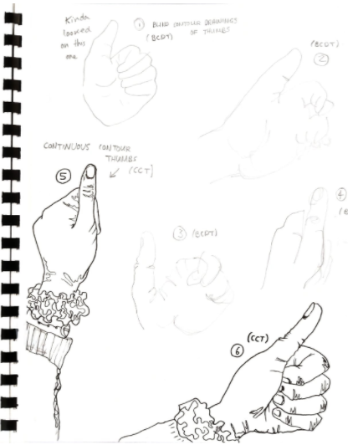  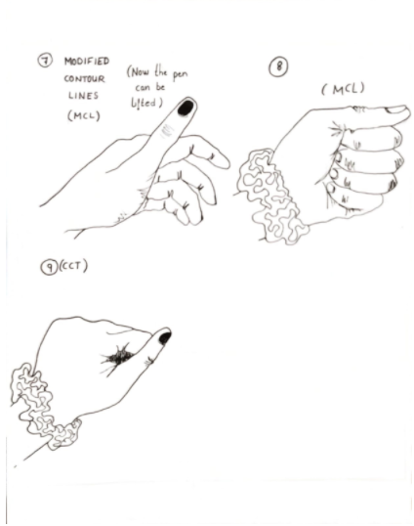  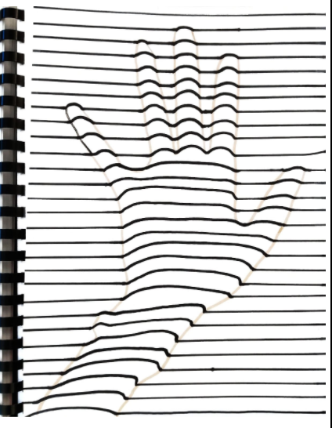  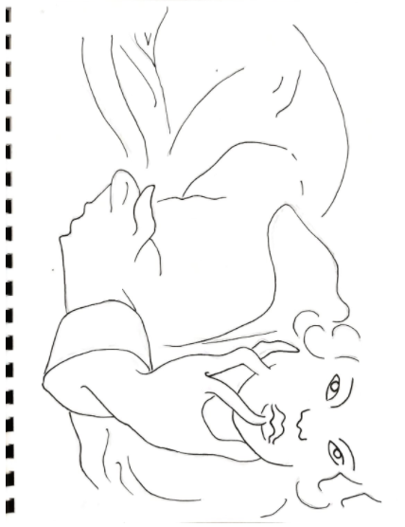
Design Assignments | I learned that if I create a pencil sketch and it doesn’t quite fit the paper I should create another one instead of being lazy and erasing it and drawing with ink with no reference.  I learned to do a better job drawing the inner edges and proportions | February, Full Page  February, Full Page | 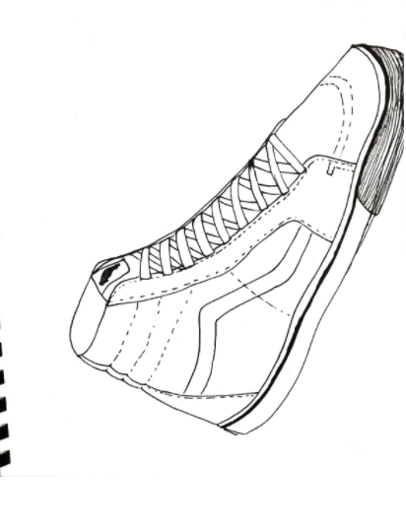  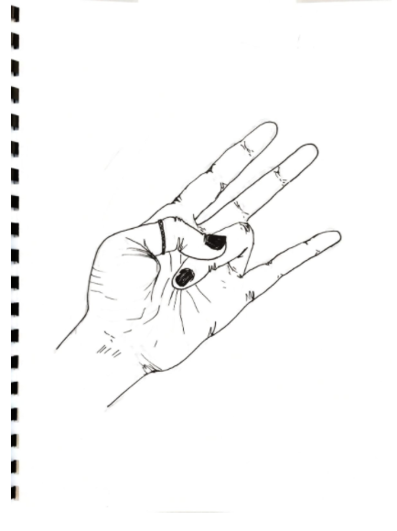

Throughout this unit, I monitored this student’s progress by checking in on her in class, giving her feedback in her sketchbook when she turned it in and by observing her progress in her own words when the class got together to do a miniature critique on the shoe drawing and the final hand drawing. As this student worked through the Line Unit, she expressed that she wanted to draw with more detail. I encouraged her to focus on the subject and not so much what she thinks the subject looks like, when drawing from life. This portfolio keeper allows us to see how students summatively reflect on how they progressed and what they were thinking about in the process and completion of each assignment on top of the many formative assessments already mentioned. I agree with this student in her last statement, and I saw improvement in attention to detail and proportions from the first and the last time that she drew her hands in this unit. Formative check-ins and sketchbook feedback as well as student group shares of assignments and mini critiques of work all played into the development of this student’s skills.

Evidence #2:

Another piece of evidence is of a student’s progress in completing an observational drawing of sunglasses for the Value unit. I used in-person check-ins with this specific student during class to monitor their well-being, as they were clearly having a rough day, and took that formative assessment into consideration when deciding how to approach the student later on.

I could not understand the student when they tried to tell me what was wrong during class, so I asked them if that was a good place for them to be at the moment and I told them that they were welcome to go anywhere they needed to feel comfortable and safe, but that they are safe in our class. After engaging with them for a bit, I asked the student if they’d like a few moments to relax and they said yes so I left them where they were and circled the class, with an eye on them from across the room to make sure they were ok. My formative assessment helped me understand where the student was coming from and how to support them in the moment by giving them what they needed, space, and patience. The student took a few moments to relax and eventually got into drawing their sunglasses. I tried not to make a big deal out of it once the student was among their peers, as the student had retreated into a corner of the classroom earlier to sit down and cry.

After class, and once I had checked in with them the next day and heard that the bad news had turned into good news, I wrote this note in their sketchbook about the sunglasses that they drew in class. I believed that the circumstance of the day hindered the student’s ability and they may not have reached their full potential for this assignment. The student had expressed that they weren’t very proud of the sunglasses they drew. So, I did not officially assess it when it came time to put their grade in the gradebook. This note was written with knowledge of the student, knowing that they would likely do their best to finish the sunglasses. After reading this feedback, the student asked me for help in finishing this and we worked together on the pieces that they were missing in the checkboxes. We worked from the sunglasses that he had made in class and I showed him techniques for adding more value using a smooth shading technique and how to blend those values with a blending stick. I also showed him how to add more values by drawing a quick value scale for him and counting how many values he saw in the drawing already. We worked together with erasers and different pencils and more layers of graphite to add more values to the drawing. We talked about where darker values would be, for example in the shadow, and where midtones and lighter and the lightest values would be. 