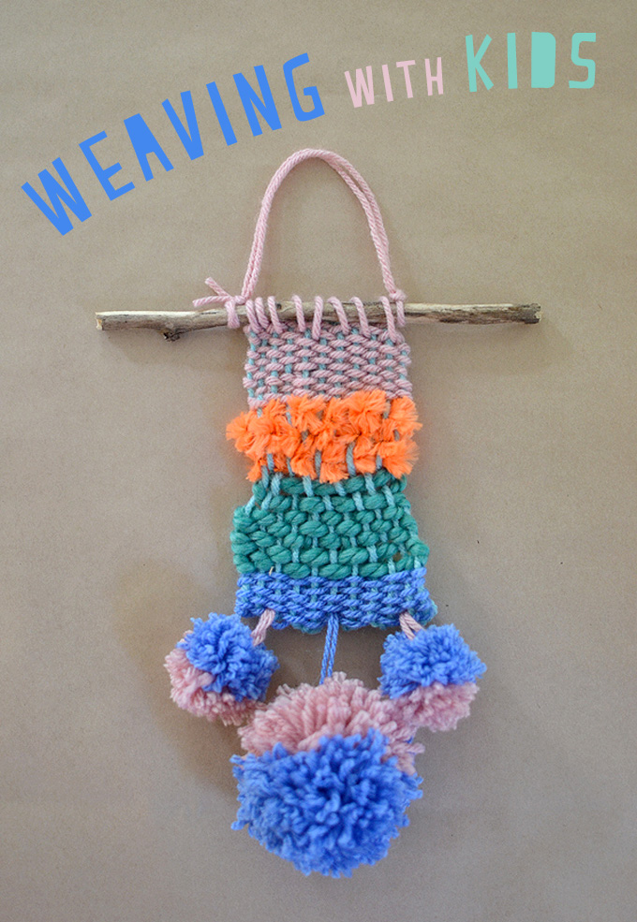
Weaving Around the World!

Teacher: Rachael Wells

Grade Level or class: 5th Grade

NCAS Standards:
Artistic Process: Creating
Anchor Standard: Generate and conceptualize artistic ideas and work
Performance Indicators: VA:Cr1.2.3a Apply knowledge of available resources, tools, and technologies to investigate personal ideas through the art-making process

Artistic Process: Connecting
Anchor Standard: Synthesize and relate knowledge and personal experiences to make art.
Performance Indicators: Va:Cn10.1.5a apply formal and conceptual vocabularies of art and design to view surroundings in new ways through art making.

Project Summary and Rationale:
What are you wearing? Maybe a pair of pants and a shirt. Maybe a skirt, or even a dress. How are these things made, you might ask? Weaving! People first started weaving as early as forty thousand years ago! People all over the world saw the ways that spiders wove their webs, how beavers built their dams and how birds built their nests and used those examples in their weaving. They would weave things such as rugs, socks, blankets, baskets and clothes. Weaving started out as a practice necessary to make these things, and as machines took the place of humans, weaving became more of an art form. Weaving is still done by hand to make intricate and meaningful artworks such as tapestries and blankets. Whether it is done by a machine or by hand, weaving is everywhere!

This lesson will inform students of the importance of this textile artform. They will learn vocabulary of weaving and see examples of historical woven creations. In creating their own weaving, they will develop an appreciation for the woven items that they use daily, and for the people who used to weave all of these things by hand.

Enduring Understandings
- Individual aesthetic and empathetic awareness developed through engagement with art can lead to understanding and appreciation of self, others, the natural world, and constructed environments.
- People develop ideas and understandings of society, culture, and history through their interactions with and analysis of art.
Essential Questions
- How does art help us understand the lives of people of different times, places, and cultures?
- How does art preserve aspects of life?
- What can we learn from our responses to art?

Knowledge Objectives/Learning Targets-you should have at least 4 total
Students will:
- Know a brief history of weaving.
- Know the purpose of weaving.
- Know the terms used to describe parts of a weaving.

Skills Objectives/Learning Targets
Students will:
- Be able to express their ideas on what in the world is woven.
- Be able to create their own design on a cardboard loom.
- Be able to draw connections from history to their own artwork.

Materials: Powerpoint with pictures of historical weaving examples, cardboard looms, several balls of yarn, scissors at each table, trays at each table with arm length pieces of yarn to use, and tape.
Resources: https://www.slideshare.net/bapuji37581/history-of-weaving-42232292
Vocabulary:
Loom- A frame used for weaving fabric.
Warp- The strong, tight threads that are strung onto a loom for weaving.
Weft- The fibers that are woven through the warp to create the fabric.

Motivation:
- Woven examples
- Demo of weaving.
- https://www.nytimes.com/video/world/100000005142711/weaving-around-the-world.html

Set up:
- Have all looms prepared with the warp completed. Put names on the back of looms with tape.
- Place blanket over rugs.
- Place looms with names facing up in a circle on the blanket.
- Write agenda and term definitions on the little white board in the front of the room.
- Place an arms length of thread (all the same color) with each loom).
- Have arms length pieces of different colored thread ready at tables with scissors.

Lesson Sequence:
Introduction of the lesson:
- Greet students at the door, have them sit in a circle on the blanket I brought in.
- Everyone sits at the piece of cardboard with ther name on it. They cannot touch the loom or thread yet.
- What are these things? What are they used for? Explain what a loom is.
- Look down at the blanket you’re sitting on. How was this blanket made?
- Where do clothes come from? How do you think clothes are made?
- Show class the stuffed animal and other examples of woven things.

Implementation of the lesson-
- Explain to students that clothes are made by weaving threads together to make cloth and then the cloth is cut into shapes and sewn together to make clothes.
- Present the video from NY Times
- Ask students to turn their looms over and show them how to start weaving with their assigned piece of thread with a video (for a good visual angle).
- After the video, they may start their weaving in the circle with me and I can help them get started.
Closure of the Lesson
- Go around the circle and have students say what they liked best about the lesson
- Offer the students the opportunity to share their work if they’d like to, making sure not to force students into sharing

Differentiated Strategies:
- Modify tools and materials for use by students with disabilities. String the looms with black and white yarn to help differentiate.
- Adjust timelines to provide additional time for students with disabilities to complete work.
- Provide various means through which students with disabilities can communicate their ideas or questions.
- Encourage students with high ability to modify or interpret outcomes to capture greater levels of complexity or sophistication in interpretations of ideas or topics.
- Provide varying means through which students can express what they have learned.
- Encourage students to explore various subtopics of a larger topic or issue.
- Identify student readiness and learning differences and modify instruction to meet varying needs of students.
- Have student work in group with defined jobs, allowing for writing and verbal abilities to share thoughts/opinions.

Assessment:
Formative: Student check-ins while they work.
Summative: A group sharing circle at the end of class.

