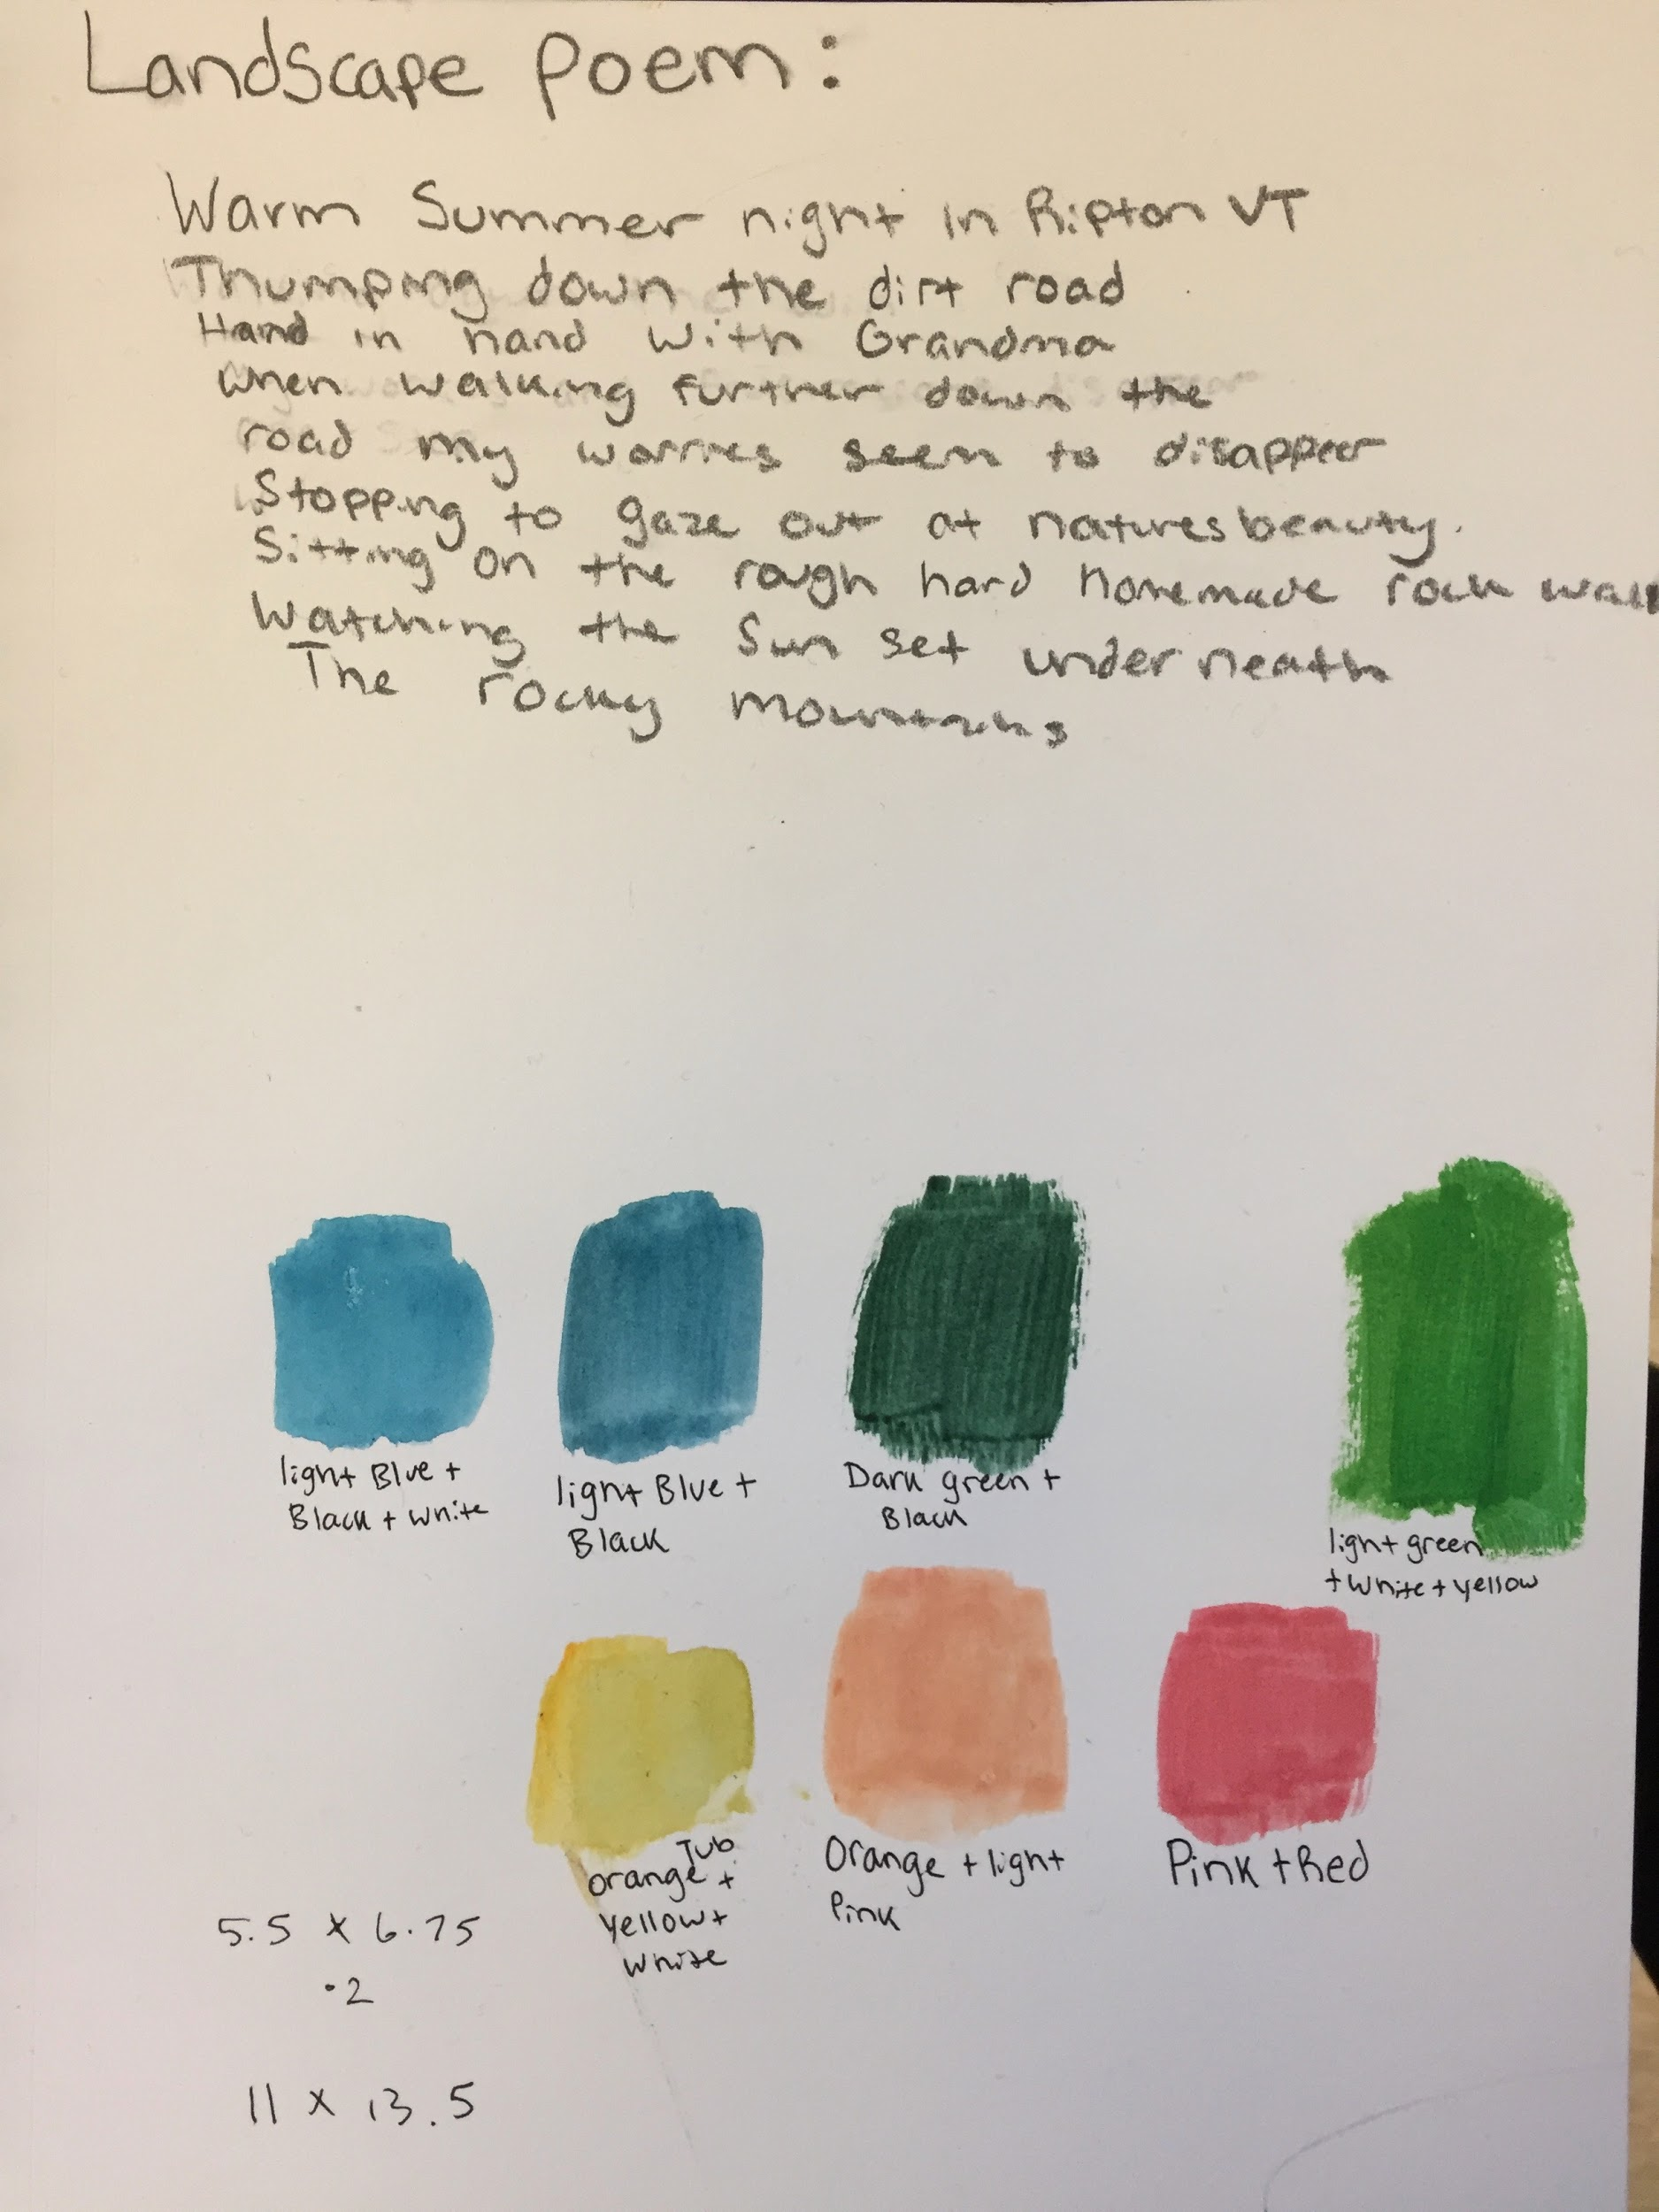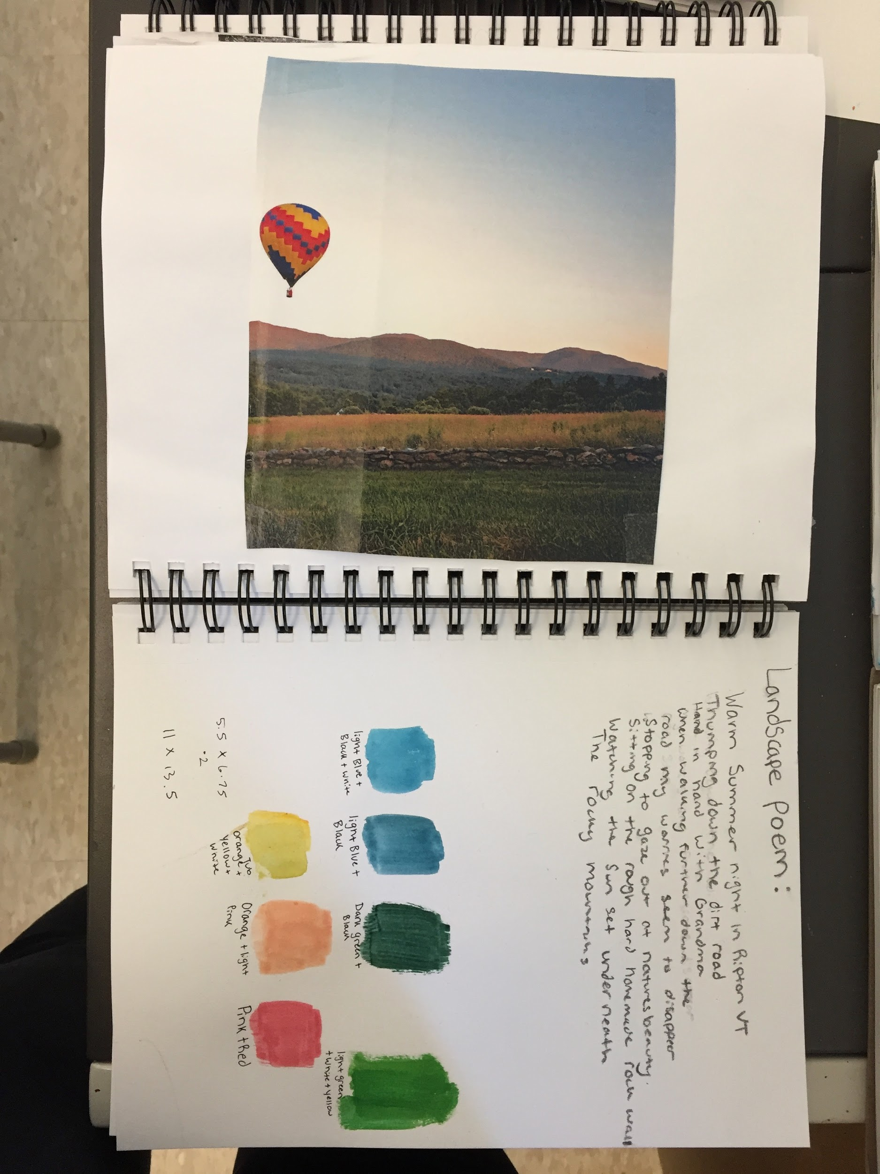

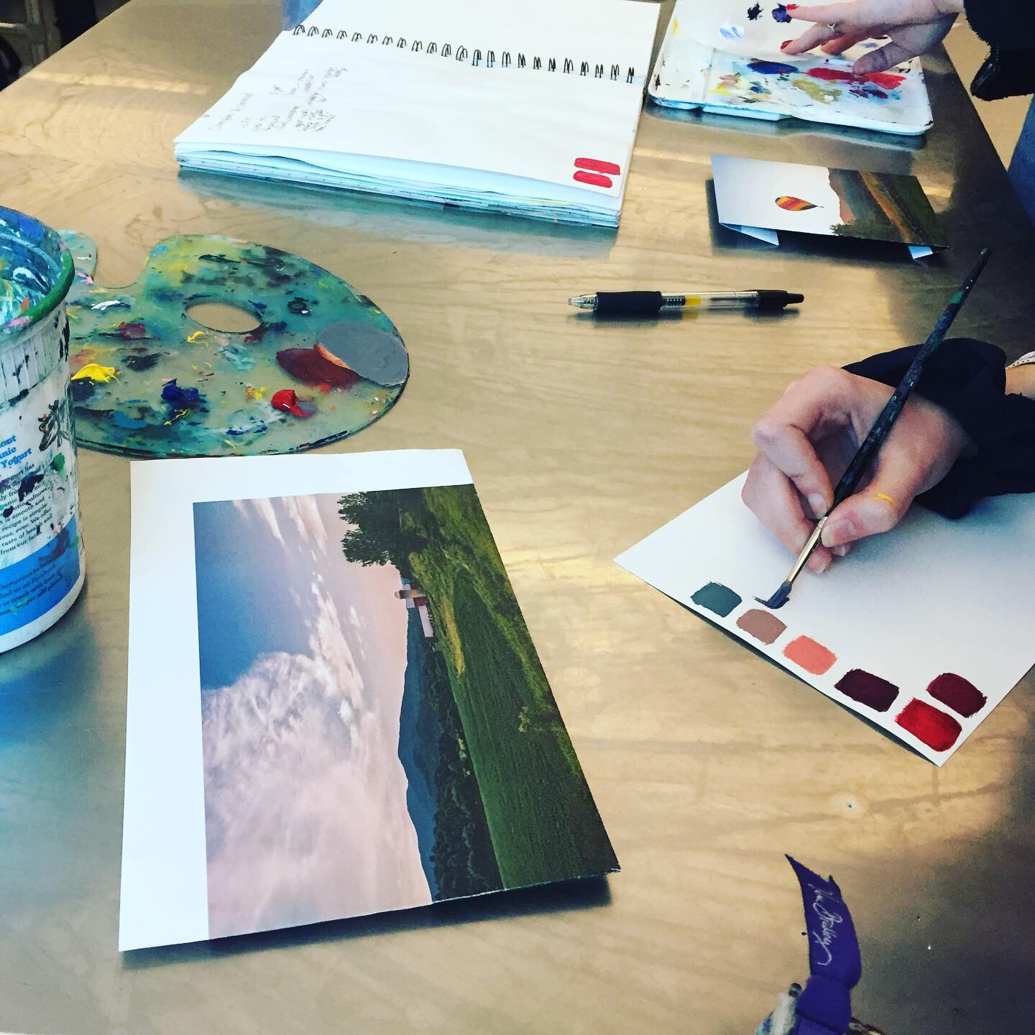
In my experience as a student teacher, I was able to collaborate with two professionals in order to enhance the relevance of a Landscape Painting unit. Throughout the unit, students had been painting from pre-picked photographs that my mentor teacher and I found on the internet. I wondered how I could get that part of the lesson to be more relevant to our students who have all experienced what it's like to live in a Vermont landscape. I wanted to enhance the relevance of the subject by, as this PC says, “applying perspectives from varied disciplines in authentic contexts” or in other words, bringing new perspectives to the classroom in the context of painting Vermont landscapes.

Given that this unit occurred during the cold winter months, plein air painting was not the best option. I contacted my friend who is an established local photographer and he granted us the permission to choose 25 of his landscape photographs for the students to pick from for their reference. On the day that we introduced the unit piece, I started class by telling our students about my collaboration with a local Vermont photographer, and I told them that if they wished to do so, this photographer was interested in accessing photos of their paintings to create a booklet of their efforts. I then explained that we were doing Vermont Landscapes because everyone in that class, no matter how long they've been in this state, has at least some experience living in a Vermont landscape. What makes a landscape painting so exceptional is the context that the artist incorporates into it from their own experience living in that landscape. Students were then asked to take a moment of silence and think about their drive from home to school every day, and count the barns that they see on their way there. This is a common type of landmark, as they are scattered all over Vermont. Then, students shared the number of barns they see on their usual way to school. This exercise was geared toward getting students to think about what they have experienced, living among the types of landscapes that they would see in the local landscape photographs. Then students picked their reference photo according to what they relate to the most. The photographer was invited to come in for the final critique but this could not happen due to the COVID-19 outbreak. He was however, able to attend the online version of our critique.

Our students got to further develop their connection with their reference photo through ekphrasis poetry. An example of a poem written by a student in connection with her photo, is shown above. Ekphrasis poetry is poetry written to develop the author’s own interpretation of, or meaning for an image. My mentor teacher and I contacted another teacher from the school who specializes in poetry. I picked out two photos from the photographer for him to make ekphrastic poems from, and he came in to read those poems to our students. He led our students through a workshop on writing their own ekphrastic poem based on the reference photo they chose. This collaboration allowed the art teachers to introduce a way of making meaning from a photograph in a professional manner, despite our lack of poetry instruction experience.

The values of having these two people involved was to get new voices into the space, and to enhance the relevance of painting landscapes through real life artist examples and experience. In doing so, we explored the valuable relationships that we can make with a place, and how that can bring more life to a painting from a reference photograph.

