CVU Faculty Scales: Personalization Strand
Focus for Winter/Spring 2020

Purpose: Individually and collectively, to grow within our targets in the areas of Proficiency, Personalization, or Social Emotional Learning.

Personalized Learning
I facilitate advisory plans and activities in order to support advisees as they make decisions. | I use my knowledge of available resources and of my advisees to support them as they make decisions and personalize their experiences. | I create an environment in advisory that promotes self-direction and self-advocacy and helps students identify diverse opportunities in and beyond school. | I help my students plan for life after high school in a way that aligns with their individual experiences, values, and goals.
I am working to recognize and understand how student voice can improve learning and engagement in my classes. | I am beginning to incorporate student voice into specific units or lessons in my classes by asking students what they want and need. | I design units that incorporate student voice in my classes. | I intentionally structure my course/s so that students have a voice in what they learn and how they meet the targets and standards.
I am working to recognize and understand how co-creation can improve learning and engagement in my classes. | I am beginning to incorporate the idea of co-creation into specific units or lessons in my classes by working with students to develop the products, outcomes, plans, timelines, and/or goals. | I design units that incorporate co-creation in my classes. | I intentionally structure my course/s to honor the co-creation process to help develop students with agency, autonomy, and purpose.
I am working to recognize and understand how social construction can improve learning and engagement in my classes. | I am beginning to incorporate the idea of social construction into specific units or lessons in my classes by creating time and space for students to theorize and investigate together. | I design units that incorporate social construction in my classes. | I intentionally structure my course/s to harness the power of social construction.
I am working to recognize and understand how self-discovery can improve learning and engagement in my classes. | I am beginning to incorporate the idea of self-discovery into specific units or lessons in my classes by facilitating interest inventories and exposure activities. | I design units that incorporate self-discovery in my classes. | I intentionally structure my course/s with student self-discovery as a core value.

Task:
- Connection: What environment (classroom, advisory, caseload, other) do you plan to focus on for the next three weeks? Highlight the scale(s) above that you plan to use to demonstrate growth in personalization.

- Reflection: In thinking about the scale you are committing to working on, what new learning have you experienced today? What do you see as your greatest needs, strengths, or obstacles as you work to apply that new learning?

I have learned that the large topics and their broad definitions are only useful to a point with personalization. That my idea of what it is, and likely the assumption of our students, may need to shift. I am doing more than I realized.

- Goal Setting:
  - General: How would you like things to be different at the end of four weeks? What would your classroom/context look like if you were to see improvement in this area?
  - Specific: What are specific steps, tasks, or practices that you will implement/try in the next week in order to move toward your general goal?

I would like to work with Eve to explore the concept of Harkness discussion using an image as catalyst (instead of text).
I will look for imagery that I think will work toward this goal that fits with the curriculum.
I will share the 4step document and scales with Eve prior to Monday

((Also, another goal is to consider the co-creation of a personal interest project for the end of semester for my Intro class… what I initially thought I’d be focusing on - ha ha))

- Resources and Support: What resources or support would you like from us to help you move toward your general or specific goals? (Readings, video, meeting/planning time, other).

Meeting/planning time with Eve!

Reflection questions:
- What have I learned that I can carry forward and hope to change or implement in the next months
I have learned about how to use an art image as a catalyst for a Harkness discussion. I have discovered how to scaffold the learning to get students ready for a harkness discussion.

- Describe an idea that is more of a reach, but something you would like to strive for to implement in August
Allowing more opportunities for students to think through things and discuss them as a way to engage with their learning versus a teacher-directed path.

- Explain a big idea or question that I am still pondering in relation to personalized learning.
When will our school consider more of a student directed scheduling system and how can we adapt our curricular offerings and curriculum within classes to better meet the interests of our students? Will we move toward 20% time and/or RISE ½-1 day per week? ;)

Below is the self-reflection that Eve, the English teacher that we collaborated with, uses with her students in Harkness discussion in her class. She gave this to us as a reference for questions we may ask our students.

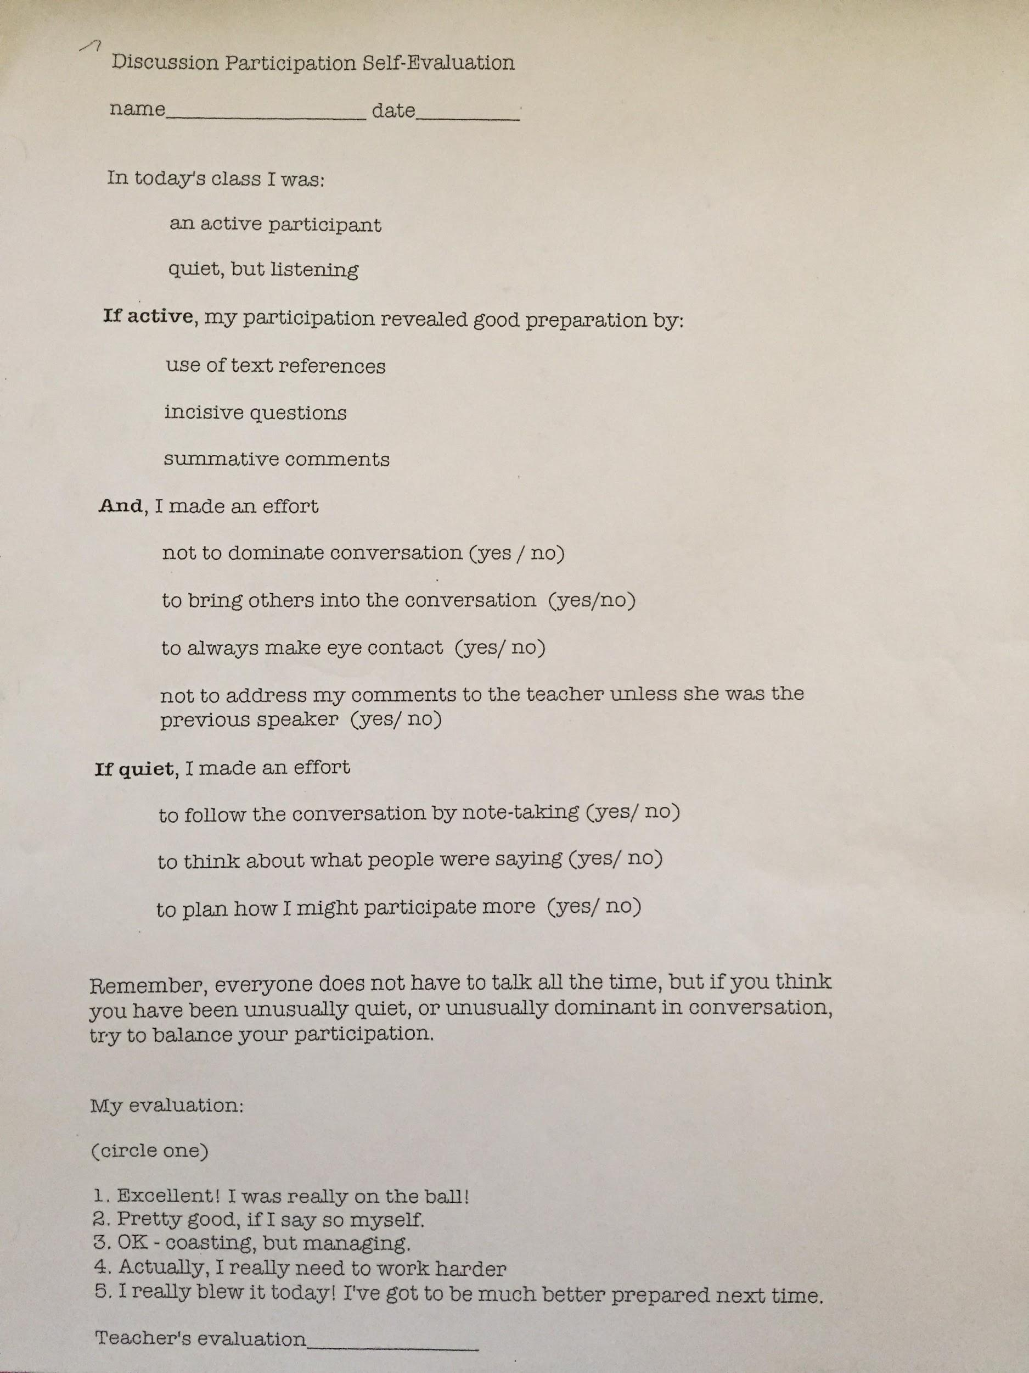

Images for Evidence #2 are on the following pages. I attended a department meeting right before the school shut down due to COVID-19 and we were given this document. These are the school graduation standards that are reviewed by teachers to be approved. Teachers in this department meeting give the department head feedback after taking a few minutes to look at their copies of the standards. This meeting also included the advancement of the profession of teaching and teaching art through the second half of the meeting, during which all teachers were involved in the process of rescheduling art shows and concerts such as CVU’s Celebrate and the Arts Night, which is a full district arts show that is hosted at CVU to showcase the work of students in visual arts, band, chorus, and theatre classes.
